

[Accredited by NAAC & NBA, Approved by AICTE New Delhi & Permanently Affiliated to JNTUH] Aziz nagar Gate, Chilkur Balaji Road, Hyderabad - 500075

DEPARTMENT OF COMPUTER SCIENCE AND ENGINEERING (ARTIFICIAL INTELLIGENCE & MACHINE LEARNING)

DJANGO

Regulation: R25

II B.TECH- I SEMESTER

LAB MANUAL

DJANGO LAB

L | T | P | C
0 | 0 | 2 | 1

B.Tech II Year I Semester Course Code: A253585
Course Outcomes:
At the end of the course, student will be able to:
- Design and Develop a responsive Web Application using HTML & CSS.
- Build a responsive Web Application using Java Script, CSS, Flex & Grid.
- Demonstrate understanding of the Django Framework
- Implement Mailing, Cache and Session Management in Django Framework
- Analyze, Design, Develop and Implement complete Web Applications using Django Framework

LIST OF EXPERIMENTS:
- Build a Responsive Web Application for Registration Form, which contains User Name, Password, Date of Birth, Gender, Mail-id, Contact Number, Address and Submit Button.
- Write a JavaScript Program to Validate Registration Page using Regular Expression.
- Build a Responsive Web Application for Shopping Cart with Registration, Login, Catalog and Cart Pages using CSS3 features, Flex and Grid.
- Basics of Django Framework & Installation of required Software’s.

- Create a shopping cart web application and add a customized admin page for product catalog management for Experiment 3
- Demonstrate Cache, Session Management for Student Login Application.
- Create a Quiz Application using Django Framework along with SQLite3.

- Create a Django application using generic views and forms
- Create an Application for Working with Mails using Django Framework
- Create an application that fetches the weather information from openweathermap.org and the display the current and historical weather information using graphical representation using chart.js implement using Django
- Case Study: Django Application for VJIT Student Portal and deploy it into GitHub.

REFERENCE BOOKS:
- “Web Technologies: HTML, CSS, JavaScript” Uttam K. Roy
- “Django for Beginners: Build Websites with Python and Django” William S. Vincent
- “Python Web Development with Django” Jeff Forcier, Paul Bissex, Wesley Chun

Web URLs:
  - W3Schools Web Development Tutorials https://www.w3schools.com
  - JavaScript Regular Expressions Guide – MDN https://developer.mozilla.org/en-US/docs/Web/JavaScript/Guide/Regular_Expressions
  - Python Official Documentation https://www.python.org/doc/
  - Python Tutorial (W3Schools) https://www.w3schools.com/python/
  - Django Official Documentation https://docs.djangoproject.com
  - Django Tutorials https://djangoproject.com/start/

INDEX

S.NO | Experiment | Page No.
1 | WEEK1: Build a Responsive Web Application for Registration Form, which contains User Name, Password, Date of Birth, Gender, Mail-id, Contact Number, Address and Submit Button | 4-12
2 | WEEK2: Write a JavaScript Program to Validate Registration Page using Regular Expression. | 13-16
3 | WEEK3: Build a Responsive Web Application for Shopping Cart with Registration, Login, Catalog and Cart Pages using CSS3 features, Flex and Grid. | 17-31
4 | WEEK4: Basics of Django Framework & Installation of required Software’s | 32-38
5 | WEEK5: Create a shopping cart web application and add a customized admin page for product catalog management for Experiment 3 | 39-49
6 | WEEK6: Demonstrate Cache, Session Management for Student Login Application | 50-56
7 | WEEK7: Create a Quiz Application using Django Framework along with SQLite3 | 57-63
8 | WEEK8: Create a Django application using generic views and forms | 64-72
9 | WEEK9: Create an Application for Working with Mails using Django Framework | 73-91
10 | WEEK10: Create an application that fetches the weather information from openweathermap.org and the display the current and historical weather information using graphical representation using chart.js implement using Django | 92-110
11 | WEEK11:Case Study: Django Application for VJIT Student Portal and deploy it into GitHub | 111-115

Week1: Build a Responsive Web Application for Registration Form, which contains User Name, Password, Date of Birth, Gender, Mail-id, Contact Number, Address and Submit Button.

PROGRAM:
STATIC REGISTRATION FORM –HTML
<!DOCTYPE html>
<html lang="en">
<head>
<meta charset="UTF-8">
<meta name="viewport" content="width=device-width, initial-scale=1.0">
<title>Registration Form</title>
</head>
<body>
<h2>Registration Form</h2>
<form>
<p>
<label for="username">User Name:</label><br>
<input type="text" id="username" name="username" required>
</p>
<p>
<label for="password">Password:</label><br>
<input type="password" id="password" name="password" required>
</p>
<p>
<label for="dob">Date of Birth:</label><br>

<input type="date" id="dob" name="dob" required>
</p>
<p>
<label>Gender:</label><br>
<input type="radio" name="gender" value="male" required> Male
<input type="radio" name="gender" value="female" required> Female
<input type="radio" name="gender" value="other" required> Other
</p>
<p>
<label for="email">Mail-id:</label><br>
<input type="email" id="email" name="email" required>
</p>
<p>
<label for="contact">Contact Number:</label><br>
<input type="tel" id="contact" name="contact" pattern="[0-9]{10}" placeholder="10-digit number" required>
</p>
<p>
<label for="address">Address:</label><br>
<textarea id="address" name="address" rows="3" required></textarea>
</p>
<p>
<button type="submit">Submit</button>
</p>

</form>
</body>
</html>

OUTPUT:
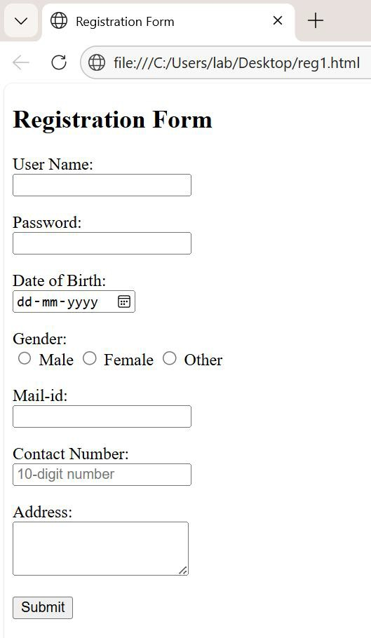

PROGRAM:

Responsive Web Application using CSS,JAVASCRIPT
<!--WEEK1:Build a Responsive Web Application for Registration Form, which contains User Name, Password, Date of Birth, Gender, Mail-id, Contact Number, Address and Submit Button--!>
<!DOCTYPE html>
<html lang="en">
<head>
<meta charset="UTF-8">
<meta name="viewport" content="width=device-width, initial-scale=1.0">
<title>Registration Form</title>
<style> body {
font-family: Arial, sans-serif; background: #f4f7f8; display: flex;
justify-content: center; align-items: center; min-height: 100vh; margin: 0;
}

.container { background: #fff; padding: 20px 30px; border-radius: 8px;
box-shadow: 0 4px 8px rgba(0,0,0,0.1); max-width: 500px;
width: 100%;

}

h2 {
text-align: center; margin-bottom: 20px; color: #333;
}

.form-group {
margin-bottom: 15px;
}

label {
display: block; margin-bottom: 5px; font-weight: bold; color: #555;
}

input, select, textarea { width: 100%; padding: 10px; border: 1px solid #ccc; border-radius: 5px; font-size: 14px;
}

textarea { resize: vertical;
}

.radio-inline { display: flex;
gap: 20px; /* spacing between options */ margin-top: 8px;
}

.radio-inline label { display: flex;
align-items: center; font-size: 14px; cursor: pointer;
}

.radio-inline input[type="radio"] { margin-right: 6px;
}

button { width: 100%;
padding: 12px; background: #007BFF; color: #fff;
border: none; border-radius: 5px; font-size: 16px; cursor: pointer;
}

button:hover { background: #0056b3;
}

/* Responsive Design */ @media (max-width: 600px) {
.container { padding: 15px;
}
h2 {
font-size: 20px;
}
}
</style>
</head>
<body>
<div class="container">
<h2>Registration Form</h2>
<form id="registrationForm">
<div class="form-group">
<label for="username">User Name</label>
<input type="text" id="username" name="username" required>
</div>

<div class="form-group">
<label for="password">Password</label>
<input type="password" id="password" name="password" required>
</div>

<div class="form-group">
<label for="dob">Date of Birth</label>
<input type="date" id="dob" name="dob" required>
</div>

<div class="form-group">
<div class="radio-inline">
<label>Gender:</label>
<input type="radio" name="gender" value="male" required>Male
<input type="radio" name="gender" value="female" required>Female
<input type="radio" name="gender" value="other" required>Other
</div> </div>
<div class="form-group">
<label for="email">Mail-id</label>
<input type="email" id="email" name="email" required>
</div>

<div class="form-group">
<label for="contact">Contact Number</label>
<input type="tel" id="contact" name="contact" pattern="[0-9]{10}" placeholder="10-digit number" required>
</div>

<div class="form-group">
<label for="address">Address</label>
<textarea id="address" name="address" rows="3" required></textarea>
</div>

<button type="submit">Submit</button>
</form>

</div>
<script> document.getElementById("registrationForm").addEventListener("submit",
function(event) {
event.preventDefault(); // Prevent form submission for demo alert("Form submitted successfully!");
});
</script>
</body>
</html>
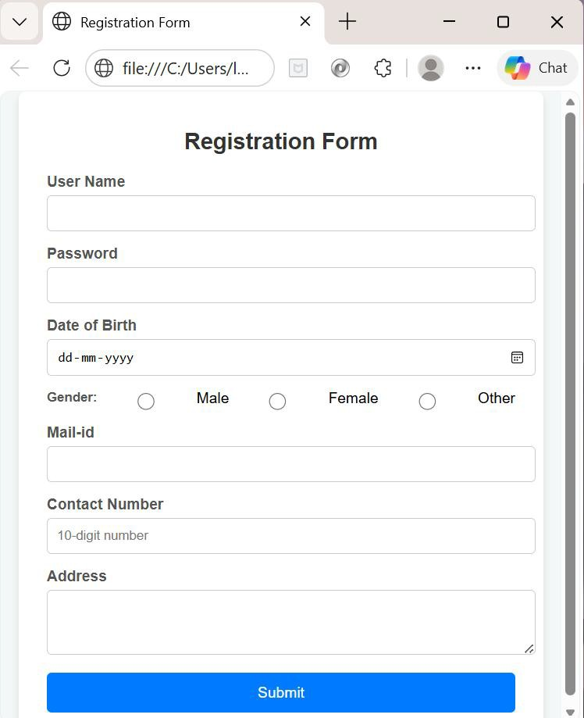

Week2 : Implement a JavaScript Program to Validate Registration Page using Regular Expression.

PROGRAM:
<!DOCTYPE html>
<html lang="en">
<head>
<meta charset="UTF-8">
<meta name="viewport" content="width=device-width, initial-scale=1.0">
<title>Registration Form with Validation</title>
</head>
<body>
<h2>Registration Form</h2>
<form id="registrationForm">
<p>
<label for="username">User Name:</label><br>
<input type="text" id="username" name="username" placeholder="Username" >
</p>

<p>
<label for="password">Password:</label><br>
<input type="password" id="password" name="password" placeholder="Password">
</p>

<p>
<label for="dob">Date of Birth:</label><br>
<input type="date" id="dob" name="dob">
</p>

<p>
<label>Gender:</label><br>
<input type="radio" name="gender" value="male"> Male
<input type="radio" name="gender" value="female" > Female
<input type="radio" name="gender" value="other" > Other
</p>

<p>

<label for="email">Mail-id:</label><br>
<input type="email" id="email" name="email" placeholder="Email id">
</p>

<p>
<label for="contact">Contact Number:</label><br>
<input type="tel" id="contact" name="contact" placeholder="10-digit number">
</p>

<p>
<label for="address">Address:</label><br>
<textarea id="address" name="address" rows="3" placeholder="address"></textarea>
</p>

<p>
<button type="submit">Submit</button>
</p>
</form>

<script> document.getElementById("registrationForm").addEventListener("submit", function(event) {
event.preventDefault(); // Prevent default submission

// Collect values
const username = document.getElementById("username").value.trim(); const password = document.getElementById("password").value.trim(); const dob = document.getElementById("dob").value;
const gender = document.querySelector('input[name="gender"]:checked');
const email = document.getElementById("email").value.trim(); const contact = document.getElementById("contact").value.trim(); const address = document.getElementById("address").value.trim();

// Regex patterns

const usernameRegex = /^[A-Za-z0-9_]{3,15}$/; // 3–15 chars, letters, numbers, underscore
const passwordRegex = /^(?=.*[A-Za-z])(?=.*\d)[A-Za-z\d]{6,}$/; // min 6 chars, at least 1 letter & 1 number
const emailRegex = /^[^\s@]+@[^\s@]+\.[^\s@]+$/; // basic email format
const contactRegex = /^[0-9]{10}$/; // exactly 10 digits

// Validation checks
if (!usernameRegex.test(username)) {
alert("Invalid Username: Use 3–15 letters, numbers, or underscores."); return;
}

if (!passwordRegex.test(password)) {
alert("Invalid Password: Must be at least 6 characters with letters and numbers.");
return;
}

if (!dob) {
alert("Please enter your Date of Birth."); return;
}

if (!gender) {
alert("Please select your Gender."); return;
}

if (!emailRegex.test(email)) { alert("Invalid Email format."); return;
}

if (!contactRegex.test(contact)) {
alert("Invalid Contact Number: Must be exactly 10 digits."); return;

}

if (address.length < 5) {
alert("Address must be at least 5 characters long."); return;
}

// If all validations pass
alert("Form submitted successfully!");
});
</script>
</body>
</html>

OUTPUT:
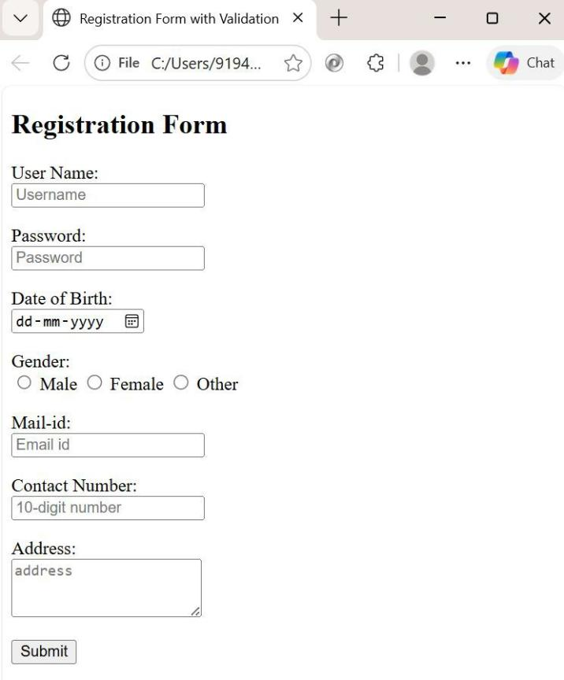
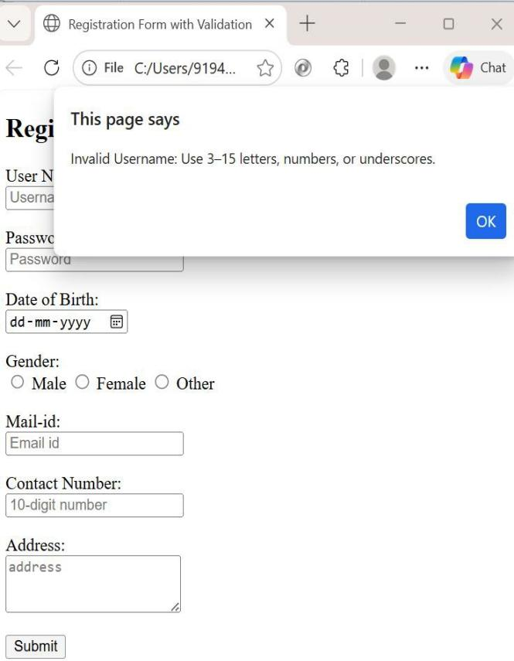

WEEK3: Build a Responsive Web Application for Shopping Cart with Registration, Login, Catalog and Cart Pages using CSS3 features, Flex and Grid

PROGRAM:
<!DOCTYPE html>
<html lang="en">

<head>
<meta charset="UTF-8">
<title>Shopping Cart</title>
<link rel="stylesheet" href="https://cdn.jsdelivr.net/npm/bootstrap@4.0.0/dist/css/bootstrap.min.cs s"crossorigin="anonymous">
<link rel="stylesheet" href="assets/css/style.css">
<link rel="icon" type="image/png" href="images/cart-icon.png">

</head>
<body>
<header class="bg-dark text-white text-center py-3">
<h1>Shopping Cart</h1>
</header>
<!-- Navbar -->
<nav class="navbar navbar-expand-lg navbar-dark bg-dark">
<a class="navbar-brand" href="#">Home</a>
<button class="navbar-toggler" type="button" data-toggle="collapse" data-target="#navbarNav">
<span class="navbar-toggler-icon"></span>
</button>

<div class="collapse navbar-collapse" id="navbarNav">
<ul class="navbar-nav ml-auto">
<!-- Catalog -->
<li class="nav-item">
<a class="nav-link" href="#catalog">Catalog</a>
</li>
<!-- Login -->
<li class="nav-item">
<a class="nav-link" href="login.html">Login</a>
</li>
<!-- Registration -->
<li class="nav-item">

<a class="nav-link" href="registration.html">Register</a>
</li>
<!-- Cart -->
<li class="nav-item">
<a class="nav-link" href="#" data-toggle="modal" data-target="#cartModal">
<img src="images/cart.jfif" alt="Cart" class="cart-icon"> Cart
</a>
</li>
</ul>
</div>
</nav>

<!-- Main -->
<div class="container">

<br>

<h3 class="text-center">Shopping Cart</h3>
<hr>

<div class="row">
<div class="col-sm-12 col-md-6 col-xl-4">
<figure class="card card-product zoom">
<div class="img-wrap"><img src="images/dress1.jfif" class="rounded p-1"></div>
<figcaption class="info-wrap">
<h4 class="title">Beautiful dress</h4>
<p class="desc">"Adorn yourself in the allure of timeless beauty with our collection, where
each dress is a masterpiece of grace and charm."</p>
<div class="rating-wrap">
«<div class="label-rating">132 reviews</div>
<div class="label-rating">154 orders </div>
<br />
<small class="text-muted">&#9733; &#9733; &#9733; &#9733; &#9734;</small>
</div> <!-- rating-wrap.// -->
</figcaption>
<div class=" bottom-wrap">
<button class="btn btn-primary add-to-cart" data-name="Beautiful Dress" data-price="220">Add to Cart</button>
<div class="price-wrap h5">

old">$180</del>
<span class="price-new">$220</span> <del class="price-

<div>
</div>
<!--price-wrap.//-->
</div>
<!--bottom-wrap.//-->

</figure>
</div>
<!--col//-->
<div class="col-sm-12 col-md-6 col-xl-4">
<figure class="card card-product zoom">
<div class="img-wrap"><img src="images/item-2.jpeg" class="rounded p-1">
</div>

<figcaption class="info-wrap">
<h4 class="title">Elegant style</h4>
<p class="desc">"Elevate your wardrobe with an essence through our collection, where
elegance becomes a signature style."</p>
<div class="rating-wrap">
<div class="label-rating">122 reviews</div>
<div class="label-rating">120 orders </div>
<br />
<small class="text-muted">&#9733; &#9733; &#9733; &#9733; &#9734;</small>
</div>

<!-- rating-wrap.//-->
</figcaption>
<div class="bottom-wrap">
<button class="btn btn-primary add-to-cart" data-name="Elegant Style" data-price="115">Add to Cart</button>

old">$180</del>
<div class="price-wrap h5">
<span class="price-new">$115</span> <del class="price-
<div>

<!--price-wrap.//-->
</div>

<!--bottom-wrap.//-->
</figure>
</div>
<!--col//-->
<div class="col-sm-12 col-md-6 col-xl-4">

<figure class="card card-product zoom">
<div class="img-wrap"><img src="images/dress3.jfif" class="rounded p-1"></div>
<figcaption class="info-wrap">
<h4 class="title">Modern fashion</h4>
<p class="desc">"Discover the epitome of modern fashion, where style meets innovation in
every stitch and silhouette."</p>
<div class="rating-wrap">
<div class="label-rating">138 reviews</div>
<div class="label-rating">159 orders</div>
<br />

<small class="text-muted">&#9733; &#9733;&#9733;&#9733;&#9734</small>
</div>
<!-- rating-wrap.//-->
</figcaption>

<div class="bottom-wrap">
<button class="btn btn-primary add-to-cart" data-name="Modern Fashion" data-price="680">Add to Cart</button>
<div class="price-wrap h5">
<span class="price-new">$680</span> <del class="price-
old">$980</del>
</div> <!-- price-wrap.//-->
</div> <!-- bottom-wrap.//-->
</figure>
</div> <!-- col //-->
</div> <!-- row.//-->

<!-- Cart Modal -->
<div class="modal fade" id="cartModal" tabindex="-1" role="dialog">
<div class="modal-dialog" role="document">
<div class="modal-content">
<div class="modal-header">

<h5 class="modal-title">Your Cart</h5>
<button type="button" class="close" data-dismiss="modal">&times;</button>
</div>
<div class="modal-body">
<ul id="cartItems" class="list-group"></ul>
<p class="mt-3 font-weight-bold">Total: $<span id="cartTotal">0</span></p>
</div>
<div class="modal-footer">
<button class="btn btn-secondary" data-dismiss="modal">Close</button>
<button class="btn btn-success">Checkout</button>
</div>
</div>
</div>
</div>

<script src="https://code.jquery.com/jquery-3.2.1.slim.min.js"></script>
<script src="https://cdn.jsdelivr.net/npm/bootstrap@4.0.0/dist/js/bootstrap.min.js"><
/script>
<script>
let cart = [];
document.querySelectorAll('.add-to-cart').forEach(btn => { btn.addEventListener('click', () => {
const name = btn.dataset.name;
const price = parseFloat(btn.dataset.price); cart.push({name, price});
updateCart();
$('#cartModal').modal('show');
});
});

function updateCart() {
const cartItems = document.getElementById('cartItems'); cartItems.innerHTML = '';
let total = 0; cart.forEach(item => {
const li = document.createElement('li'); li.className = 'list-group-item';
li.textContent = `${item.name} - $${item.price}`; cartItems.appendChild(li);
total += item.price;

});
document.getElementById('cartTotal').textContent = total.toFixed(2);
}
// Checkout function
document.querySelector('.btn-success').addEventListener('click', () => { if (cart.length === 0) {
alert("Your cart is empty!"); return;
}

let summary = "Order Summary:\n"; cart.forEach(item => {
summary += `${item.name} - $${item.price}\n`;
});
summary += `\nTotal: $${document.getElementById('cartTotal').textContent}`;

alert(summary); // Show order summary cart = []; // Clear cart after checkout updateCart(); // Refresh cart display
$('#cartModal').modal('hide'); // Close modal
});

</script>
</body>

</html>. Style.css
body {
padding-top: 80px;
}
/* product cart design */
.show-cart li { display: flex;

}

.cart-container { position: relative; display: inline-block;
}
.cart-icon {
width: 30px; /* Adjust the width and height according to your icon size */ height: 30px;
cursor: pointer;
}

/* Add a hover effect if desired */
.cart-container:hover .cart-icon {
filter: brightness(1.2); /* Adjust the brightness for the hover effect */
}
.card {
margin-bottom: 20px;
}
.card-img-top { width: 200px; height: 200px; align-self: center;
}

.card-product .img-wrap { border-radius: 3px 3px 0 0; overflow: hidden;
position: relative; height: 220px; text-align: center;
}
.card-product .img-wrap img { max-height: 100%;
max-width: 100%; object-fit: cover;
}
.card-product .info-wrap { overflow: hidden; padding: 15px;
border-top: 1px solid #eee;
}
.card-product .bottom-wrap { padding: 15px;
border-top: 1px solid #eee;
}
.label-rating { margin-right:10px; color: #333;

display: inline-block; vertical-align: middle;
}

.card-product .price-old { color: #999;

}
/* shopping cart counter */
.header{background:rgb(0, 178, 255);color:#fff;} #lblCartCount {
font-size: 12px; background: #ff0000; color: #fff;
padding: 0 5px; vertical-align: top; margin-left: -10px; }
.badge {
padding-right: 9px;
-webkit-border-radius: 9px;
-moz-border-radius: 9px; border-radius: 9px; }
.label-warning[href],

.badge-warning[href] { background-color: #c67605; }

/* shopping cart counter style */

i.fa-shopping-cart { width:2.2em; text-align:center;
vertical-align:middle;
}
.fa-shopping-cart { margin-top: 0.2em; position: relative;
}
.badge {
font-size: .25em; display: block; position: absolute; top: -.70em;
right: -.70em; width: 2.5em; height: 2.4em; line-height: 2em;
border-radius: 50%;

text-align: center; color: #fff;
background: rgba(207, 0, 15, 1);
}
/* product zoom on hover */
.zoom, .zoom-sm { transition: transform .2s;
}
.zoom:hover { transform: scale(1.05);}
.zoom-sm:hover { transform: scale(1.03);
}
/* shopping cart toast */ #product-toast { visibility: hidden;
max-width: 50px; height: 50px; margin: auto;
background-color: #333; color:#fff;
text-align:center; border-radius:2px; position:fixed;

z-index:1; left:0;right:0; bottom:30px; font-size:17px;
white-space:nowrap;
}
#product-toast #img{ width: 70px; height:50px; float:left;
padding-top:16px; padding-bottom:16px; box-sizing: border-box; background-color:#111; color:#fff; padding:16px; overflow:hidden;
white-space:nowrap;
}
#product-toast.show{ visibility:visible;
-webkit-animation:fadein 0.5s,expand 0.5s 0.5s,stay 3s 1s,shrink 0.5s 2s,fadeout 0.5s 2.5s;
animation:fadein 0.5s,expand 0.5s 0.5s,stay 3s 1s,shrink 0.5s 4s,fadeout 0.5s 4.5s;

}
@keyframes fadein {
from {bottom: 0; opacity: 0;} to {bottom: 30px; opacity: 1;}
}
@-webkit-keyframes expand { from {min-width: 50px}
to {min-width: 350px}
}
@keyframes expand { from {min-width: 50px} to {min-width: 350px}
}
@-webkit-keyframes stay { from {min-width: 350px} to {min-width: 350px}
}
@keyframes stay {
from {min-width: 350px} to {min-width: 350px}
}
@-webkit-keyframes shrink { from {min-width: 350px;}
to {min-width: 50px;}

}
@keyframes shrink { from {min-width: 350px;} to {min-width: 50px;}
}
@-webkit-keyframes fadeout { from {bottom: 30px; opacity: 1;} to {bottom: 60px; opacity: 0;}
}
@keyframes fadeout {
from {bottom: 30px; opacity: 1;} to {bottom: 60px; opacity: 0;}
}

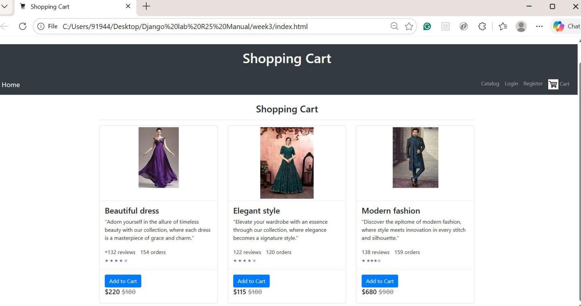

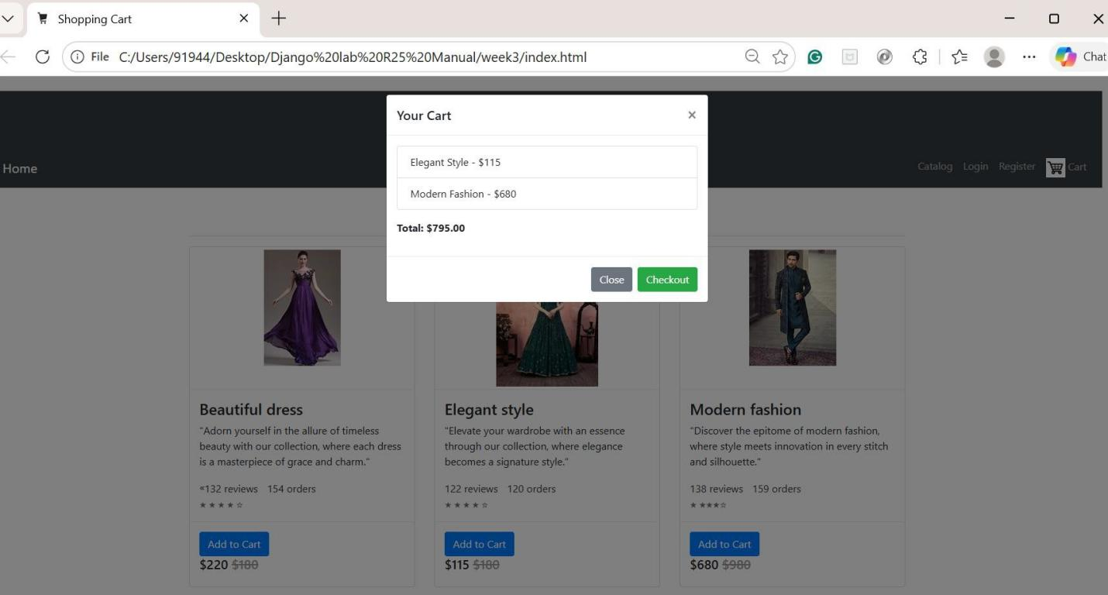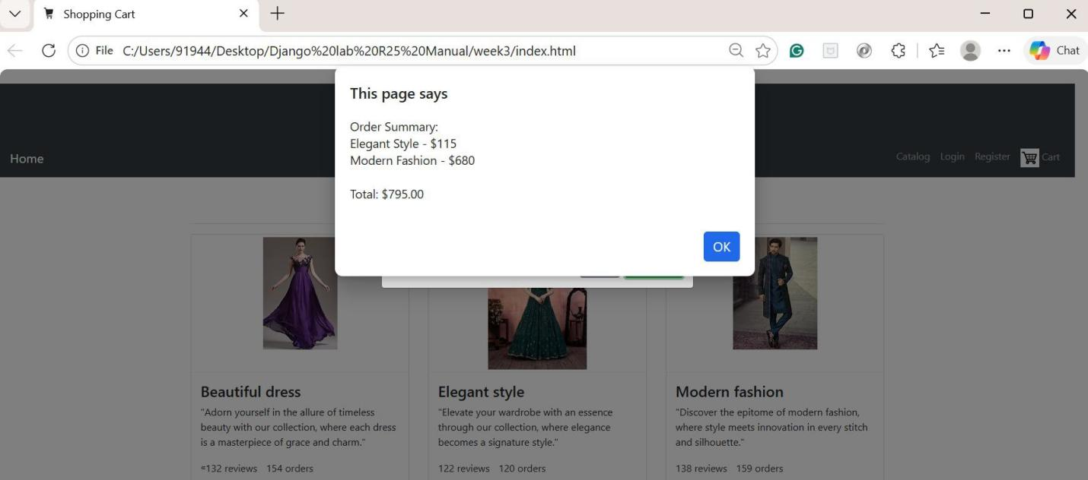

WEEK4: Basics of Django Framework & Installation of required Software’s
Step1: install Python (latest version)
python –version pip –version
pip install virtualenv or venv

Create parent directory to save all Django projects
mkdir my_django_project cd my_django_project
Step2: create virtual Enviroment
C:\>python -m venv week4 Next, Activate the enviroment
.\env\Scripts\activate Or
C:\> cd week4 C:\week4\>cd Scripts
C:\> week4\Scripts\.\activate.bat or .ps1(powershell)
Step3 : install django
pip install django

to know the version
django-admin --version
step4:create Django project
django-admin startproject website ⬅ project name

cd website
to check successfully installed Django or not runserver

python manage.py runserver
then get Django welcome page – means successfully django installed

step4: create simple application -
step4.1 To Create app
#to create app –
python manage.py startapp myapp Create these files separately HTML- index.html
CSS-style.css Javascript- script.js

Step 4.2 create subfolders in myapp static – add CSS and js files templates –HTML files
Project Structure
website/
├── myapp/
│ ├── templates/
│ │ └── myapp/
│ │ └── index.html

│ ├── static/
│ │ └── myapp/
│ │ │ └── style.css
│ │ │ └── script.js

In Templates\myapp\Index.html
{% load static %}
<!DOCTYPE html>
<html>
<head>
<link rel="stylesheet" href="{% static 'myapp/style.css' %}">
<script src="{% static 'myapp/script.js' %}"></script>
</head>
<body>
<h1>Welcome to My Django App</h1>
<button onclick="showMessage()">Click Me</button>
<p id="output"></p>
</body>
</html>
In Static\myapp\script.js
function showMessage() {
document.getElementById("output").innerText = "Hello from JavaScript!";
}
In Static\myapp\style.css
body {
font-family: Arial; background-color: #f0f0f0;
}
button { padding: 10px;
background-color: #007bff; color: white;
border: none;
}

Django Templates
Templates are HTML files with Django’s own template language (DTL) embedded. They allow you to:

- Insert dynamic data using {{ variable }}
- Control logic with {% tags %} like loops and conditionals
- Extend base layouts using {% extends %} and {% block %}
Step5 :Configure Template directory in settings.py
TEMPLATES = [
{
'BACKEND': 'django.template.backends.django.DjangoTemplates', 'DIRS': [BASE_DIR / 'templates'], # Your custom templates folder 'APP_DIRS': True,
'OPTIONS': {

'context_processors': [ 'django.template.context_processors.debug', 'django.template.context_processors.request', 'django.contrib.auth.context_processors.auth', 'django.contrib.messages.context_processors.messages',
],
},
},
]

For Static directory configure in settings.py
STATIC_URL = '/static/'

STATICFILES_DIRS = [
BASE_DIR / 'static',
]
OR
STATICFILES_DIRS = [
BASE_DIR / 'myapp' / 'static',
]

Step 6: Add myapp in installedApps settings.py
#Application definition

INSTALLED_APPS = [
'django.contrib.admin', 'django.contrib.auth', 'django.contrib.contenttypes', 'django.contrib.sessions', 'django.contrib.messages', 'django.contrib.staticfiles', 'myapp',
]

Step7: In Django, views.py and urls.py are essential for handling how your web app responds to user requests.

Views.py
This file contains view functions or classes that define what happens when a user visits a specific URL.
Purpose: It processes requests and returns responses.

Common tasks:
- Fetch data from the database
- Render templates (HTML pages)
- Handle form submissions
- Return JSON for APIs

# views.py
from django.shortcuts import render

def index(request):
return render(request, 'myapp/index.html')

urls.py The Routing System

This file maps URL patterns to the corresponding view functions or classes.
- Purpose: It connects user requests (like /home) to the right logic in views.py.
- Structure: You define urlpatterns using Django’s path() or re_path().

Example:
If not exists , we need to create urls.py in myapp
Myapp/urls.py- This file is specific to one app and defines the routes for that app’s views

# urls.py
from django.urls import path from . import views
urlpatterns = [
path('', views.index, name='index'),
]
You can also include app-specific urls.py files in your project-level urls.py using include():
website/urls.py - This file is the central URL dispatcher for your entire Django project

# project-level urls.py
from django.contrib import admin from django.urls import path, include urlpatterns = [
path('admin/', admin.site.urls),

path('', include('myapp.urls')),
]
Step9: Run application/project
python manage.py runserver

OUTPUT:
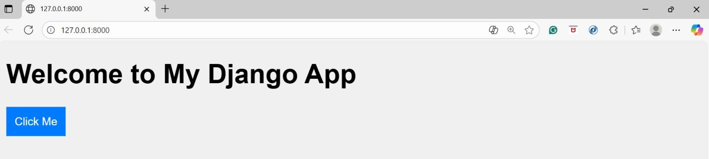
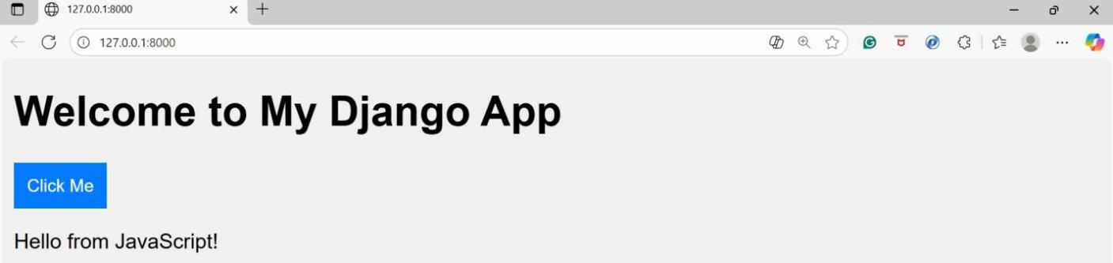

WEEK5: Create a shopping cart web application and add a customized admin page for product catalog management for Experiment 3

Project Structure:
shopping_cart/
├── manage.py
├── shopping_cart/ # Project settings
│ ├── init .py
│ ├── settings.py
│ ├── urls.py
│ └── wsgi.py
└── shop/ # Main app
├── init .py
├── admin.py
├── apps.py
├── models.py
├── views.py
├── urls.py
├── forms.py
└── templates/
├── base.html
├── registration.html
├── login.html
├── catalog.html
└── cart.html

Step1:
INSTALLED_APPS = [
'django.contrib.admin', 'django.contrib.auth', 'django.contrib.contenttypes', 'django.contrib.sessions', 'django.contrib.messages', 'django.contrib.staticfiles', 'shop',
]
LOGIN_REDIRECT_URL = 'catalog' LOGOUT_REDIRECT_URL = 'login'
Step2:
#views.py
from django.shortcuts import render, redirect, get_object_or_404 from django.contrib.auth import login
#from django.contrib.auth import logout from django.shortcuts import redirect
from django.contrib.auth.decorators import login_required from .forms import RegistrationForm, CartItemForm from .models import Product, CartItem
def register(request):
if request.method == 'POST':
form = RegistrationForm(request.POST) if form.is_valid():
user = form.save() login(request, user) return redirect('catalog')
else:
form = RegistrationForm()
return render(request, 'registration.html', {'form': form})
@login_required def catalog(request):
products = Product.objects.all()
return render(request, 'catalog.html', {'products': products})

@login_required
def add_to_cart(request, product_id):

product = get_object_or_404(Product, id=product_id)
cart_item, created = CartItem.objects.get_or_create(user=request.user, product=product)
if not created: cart_item.quantity += 1
cart_item.save() return redirect('cart')
@login_required def cart(request):
items = CartItem.objects.filter(user=request.user) total = sum(item.subtotal() for item in items)
return render(request, 'cart.html', {'items': items, 'total': total})

@login_required
def update_cart(request, item_id):
item = get_object_or_404(CartItem, id=item_id, user=request.user) if request.method == 'POST':
form = CartItemForm(request.POST, instance=item) if form.is_valid():
form.save() return redirect('cart')
#def user_logout(request):

logout(request) # clears the session
return redirect('catalog') # redirect to catalog or homepage

#models.py
from django.db import models
from django.contrib.auth.models import User

class Product(models.Model):
name = models.CharField(max_length=100)
price = models.DecimalField(max_digits=8, decimal_places=2) description = models.TextField(blank=True)
def str (self): return self.name

class CartItem(models.Model):
user = models.ForeignKey(User, on_delete=models.CASCADE) product = models.ForeignKey(Product, on_delete=models.CASCADE) quantity = models.PositiveIntegerField(default=1)

def subtotal(self):
return self.product.price * self.quantity
#forms.py
from django import forms
from django.contrib.auth.models import User
from django.contrib.auth.forms import UserCreationForm from .models import CartItem

class RegistrationForm(UserCreationForm): email = forms.EmailField(required=True)
class Meta: model = User
fields = ['username', 'email', 'password1', 'password2']

class CartItemForm(forms.ModelForm): class Meta:
model = CartItem fields = ['quantity']

# admin.py
from django.contrib import admin from .models import Product, CartItem
@admin.register(Product)
class ProductAdmin(admin.ModelAdmin): list_display = ('name', 'price', 'description') search_fields = ('name',)
@admin.register(CartItem)
class CartItemAdmin(admin.ModelAdmin): list_display = ('user', 'product', 'quantity', 'subtotal')

shop/urls.py
from django.urls import path
from django.contrib.auth import views as auth_views from . import views
urlpatterns = [
path('register/', views.register, name='register'),

path('catalog/', views.catalog, name='catalog'), path('cart/', views.cart, name='cart'),
path('add/<int:product_id>/', views.add_to_cart, name='add_to_cart'), path('update/<int:item_id>/', views.update_cart, name='update_cart'), path('login/', auth_views.LoginView.as_view(template_name='login.html'),
name='login'),
path('logout/', auth_views.LogoutView.as_view(), name='logout'),

]
Shopping_cart/Urls.py
from django.contrib import admin from django.urls import path, include
urlpatterns = [
path('admin/', admin.site.urls), path('', include('shop.urls')),

]
In shop/templates folder
Base.html
<!DOCTYPE html>
<html>
<head>
<title>Shopping Cart</title>
</head>
<body>
<nav>
<a href="{% url 'catalog' %}">Catalog</a> |
<a href="{% url 'cart' %}">Cart</a> |
{% if user.is_authenticated %}
<a href="{% url 'logout' %}">Logout</a>
{% else %}
<a href="{% url 'login' %}">Login</a> |
<a href="{% url 'register' %}">Register</a>
{% endif %}
</nav>
<hr>
{% block content %}{% endblock %}
</body>
</html> Registration.html
{% extends 'base.html' %}
{% block content %}

<h2>Create an Account</h2>
<form method="post">
{% csrf_token %}
{{ form.as_p }}
<button type="submit">Register</button>
</form>
<p>Already have an account? <a href="{% url 'login' %}">Login here</a>.</p>
{% endblock %}
Login.html
{% extends 'base.html' %}
{% block content %}
<h2>Login</h2>
<form method="post">
{% csrf_token %}
{{ form.as_p }}
<button type="submit">Login</button>
</form>
<p>Don't have an account yet? <a href="{% url 'register' %}">Register here</a>.</p>
{% endblock %}
Catalog.html
{% extends 'base.html' %}
{% block content %}
<h2>Product Catalog</h2>
<ul>
{% for product in products %}
<li>{{ product.name }} - ${{ product.price }}
<a href="{% url 'add_to_cart' product.id %}">Add to Cart</a>
</li>
{% endfor %}
</ul>
{% endblock %} Cart.html
{% extends 'base.html' %}
{% block content %}
<h2>Your Cart</h2>
<ul>
{% for item in items %}
<li>
{{ item.product.name }} (x{{ item.quantity }}) - ${{ item.subtotal }}
<form method="post" action="{% url 'update_cart' item.id %}">
{% csrf_token %}

min="1">
{{ item.quantity }}
<input type="number" name="quantity" value="{{ item.quantity }}"

<button type="submit">Update</button>

</form>
</li>
{% endfor %}
</ul>
<p>Total: ${{ total }}</p>
{% endblock %}

Commands
python manage.py makemigrations python manage.py migrate
Create Superuser:
python manage.py createsuperuser
Run Application:
python manage.py runserver

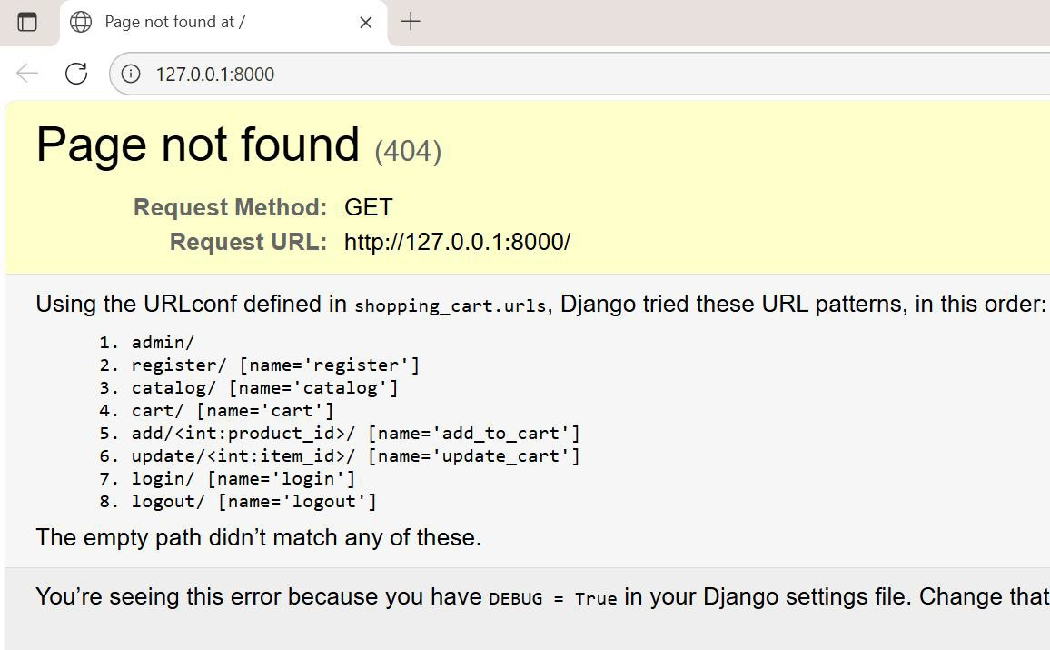

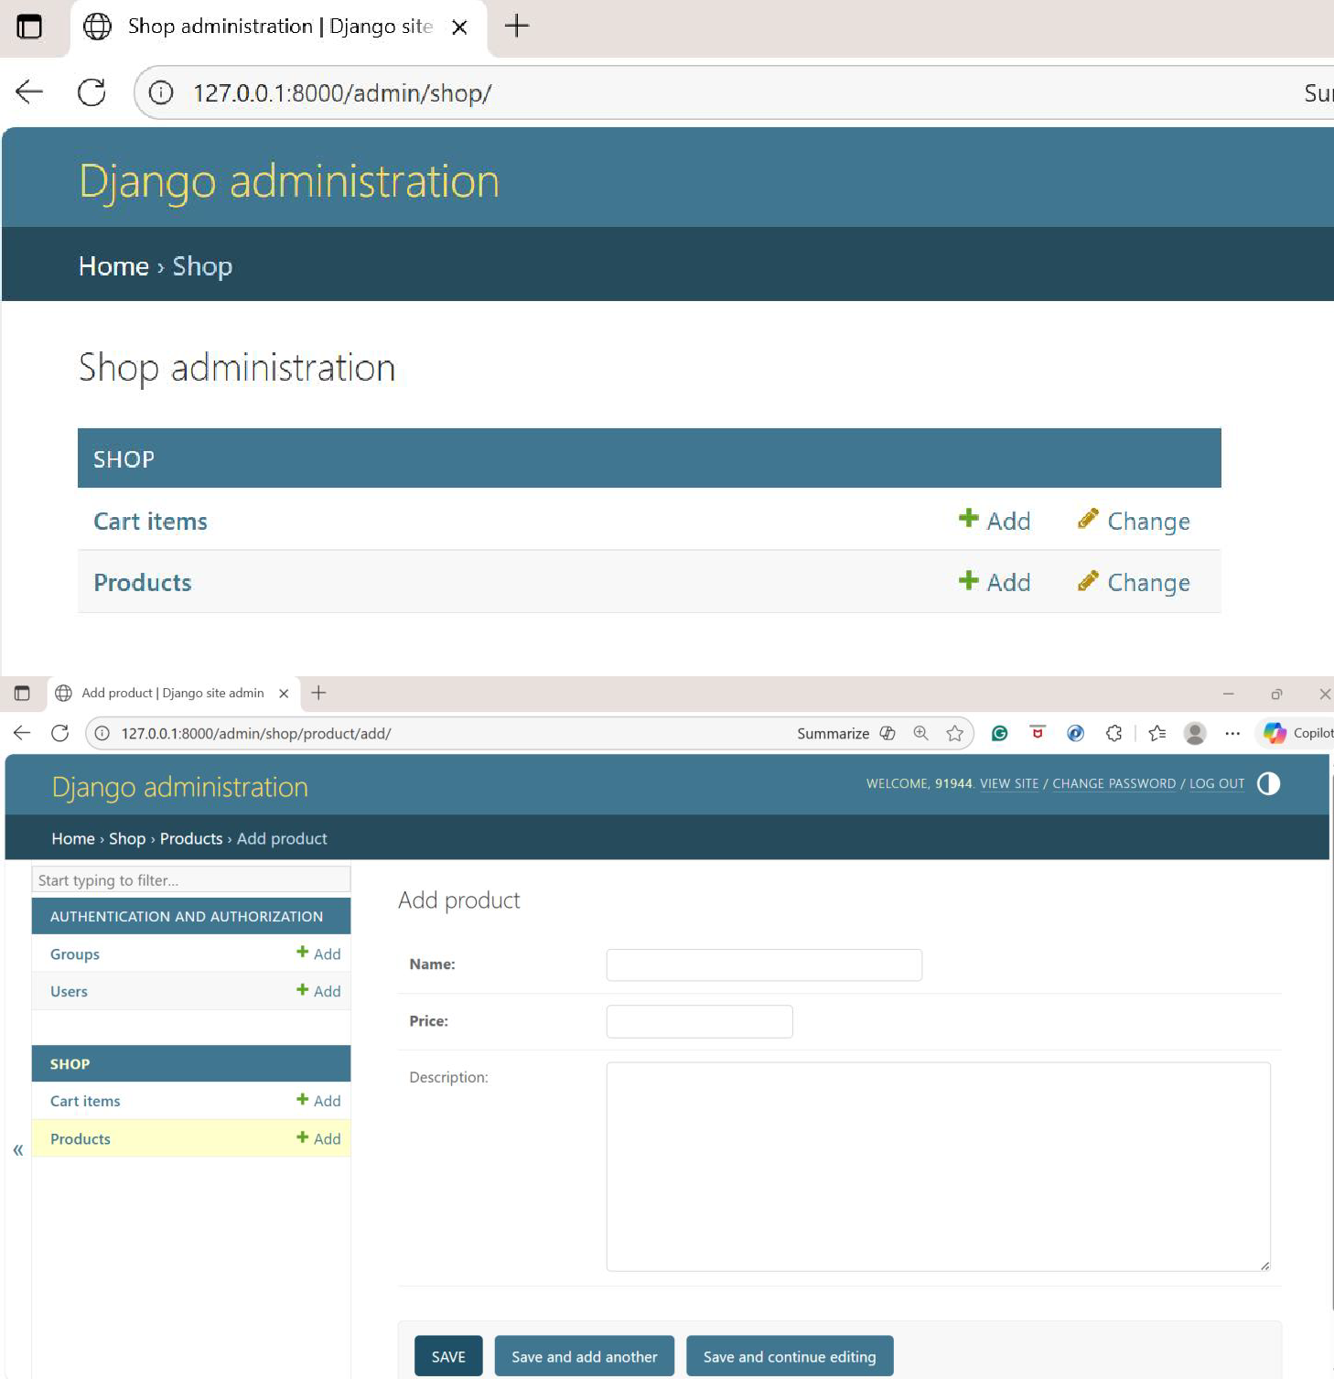

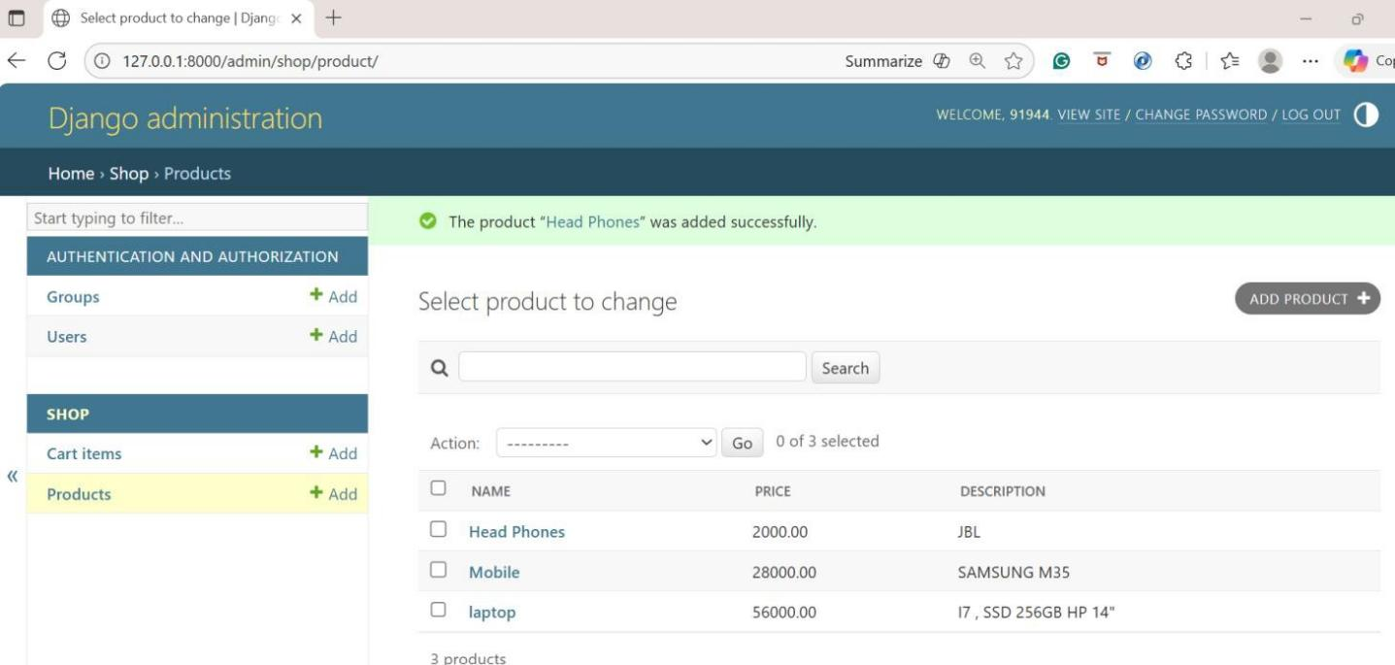

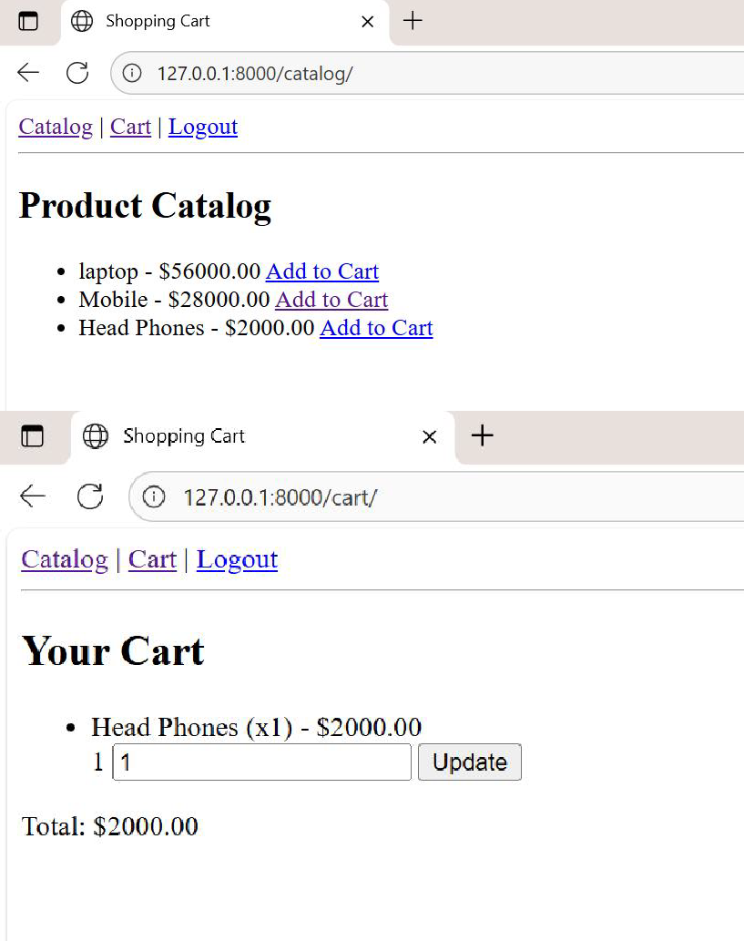

Page not found at /update/3 add more items to cart redirected to cart page automatically
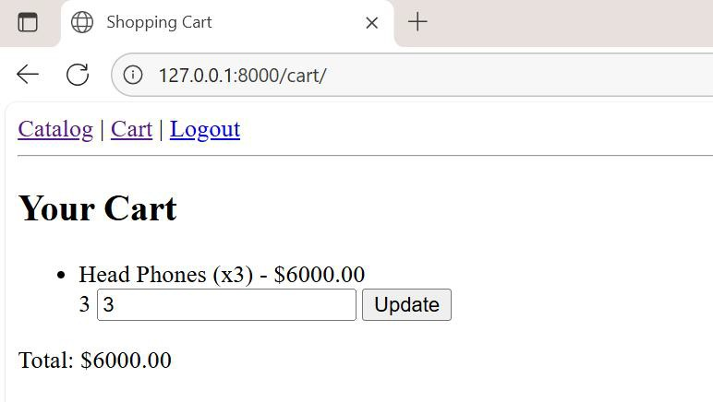

WEEK6: Demonstrate Cache, Session Management for Student Login Application.
Project Structure student_login_project/
│
├── manage.py
│
├── student_login_project/ # Project configuration
│ ├── init .py
│ ├── settings.py # Cache + session settings
│ ├── urls.py # Project-level URL routing
│ ├── asgi.py
│ └── wsgi.py
│
├── studentlogin/ # App for student login
│ ├── init .py
│ ├── admin.py # Register Student model
│ ├── apps.py
│ ├── models.py # Student model (username, password)
│ ├── views.py # Login, logout, dashboard (cache + session + cookie)
│ ├── urls.py # App-specific routes
│ ├── forms.py # (Optional) Django form for login
│ ├── middleware.py # (Optional) custom session/cookie checks
│ └── templates/
│ ├── login.html # Login form
│ └── dashboard.html # Dashboard with logout link
│
└── db.sqlite3 # Default database

Step1: Create a environment
Step2: Create Django Project –student_login_project Step3: Create App-studentlogin
Step4:
Settings.py
# Application definition

INSTALLED_APPS = [
'django.contrib.admin', 'django.contrib.auth', 'django.contrib.contenttypes', 'django.contrib.sessions',

'django.contrib.messages', 'django.contrib.staticfiles', 'studentlogin',
]

TEMPLATES = [
{
'BACKEND': 'django.template.backends.django.DjangoTemplates', 'DIRS': ['BASE_DIR /TEMPLATES'],
…..

CACHES = {
"default": {
"BACKEND": "django.core.cache.backends.locmem.LocMemCache", "LOCATION": "student-cache",
}
}

# Sessions are enabled by default
SESSION_ENGINE = "django.contrib.sessions.backends.db"

Step5:
Create a Model-Models.py
# models.py
from django.db import models
from django.contrib.auth.hashers import make_password, check_password

class Student(models.Model):
username = models.CharField(max_length=50, unique=True) password = models.CharField(max_length=128) # hashed password
def save(self, *args, **kwargs):
self.password = make_password(self.password) super().save(*args, **kwargs)

def check_password(self, raw_password):
return check_password(raw_password, self.password)

def str (self):
return self.username

Step6: Admin Module #admin.py
from django.contrib import admin from .models import Student
@admin.register(Student)
class StudentAdmin(admin.ModelAdmin): list_display = ("username",)
Step7:
# views.py
from django.shortcuts import render from django.http import HttpResponse from django.core.cache import cache from .models import Student
def login_view(request):
if request.method == "POST":
username = request.POST.get("username") password = request.POST.get("password")
# 1 Check cache first
student = cache.get(username) if not student:
try:
student = Student.objects.get(username=username) cache.set(username, student, timeout=300) # cache for 5 mins
except Student.DoesNotExist:
return HttpResponse("Invalid username")
# 2 Validate password
if student.check_password(password): # 3 Create session
request.session["student_id"] = student.id request.session["username"] = student.username

# 4 Create cookie
response = HttpResponse(f"Welcome {student.username}!") response.set_cookie("student_username", student.username,
max_age=3600)
return response else:
return HttpResponse("Invalid password")

return render(request, "login.html")

#dashboard
def dashboard_view(request):
if "student_id" in request.session:
return HttpResponse(f"Welcome {request.session['username']}! <a href='/logout/'>Logout</a>")
else:
return HttpResponse("Please login first.")

#logout
def logout_view(request): # Clear session request.session.flush()

# Clear cookie
response = HttpResponse("Logged out successfully!") response.delete_cookie("student_username")
return response

Step8:
AppLevel
# studentlogin/urls.py(AppLevel)

from django.urls import path from . import views

urlpatterns = [
path('login/', views.login_view, name='login'), path('logout/', views.logout_view, name='logout'),
path('dashboard/', views.dashboard_view, name='dashboard'), # optional
]

# student_login_project/urls.py(project level) from django.contrib import admin
from django.urls import path, include

urlpatterns = [
path('admin/', admin.site.urls),
path('', include('studentlogin.urls')), # include app routes
]

Step9:
Create Templates folder (studentlogin/templates) Login.html
<form method="post">
{% csrf_token %}
<label>Username:</label>
<input type="text" name="username" required>
<label>Password:</label>
<input type="password" name="password" required>
<button type="submit">Login</button>
</form>

Dashboard.html
<h2>Welcome {{ request.session.username }}</h2>
<p>You are logged in as student ID: {{ request.session.student_id }}</p>

<!-- Logout link -->
<a href="{% url 'logout' %}">Logout</a> Commands:
Python manage.py makemigrations Python manage.py migrate
#Create superuser
python manage.py createsuperuser Username: admin
Email address: admin@example.com Password: ********
Password (again): ******** Superuser created successfully.
python manage.py runserver

Visit: http://127.0.0.1:8000/admin/

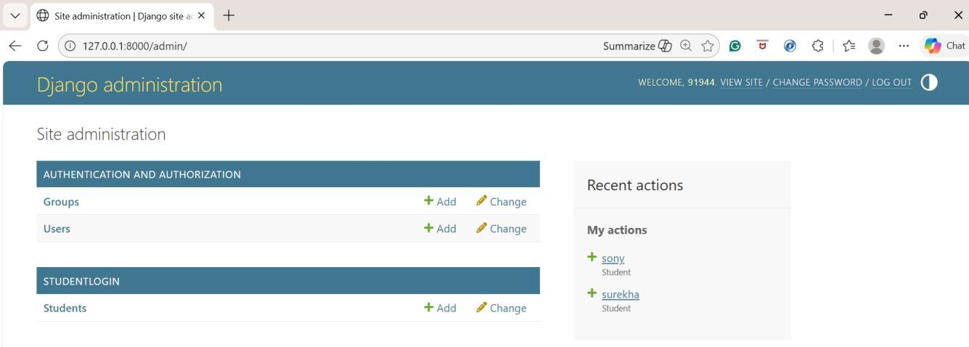

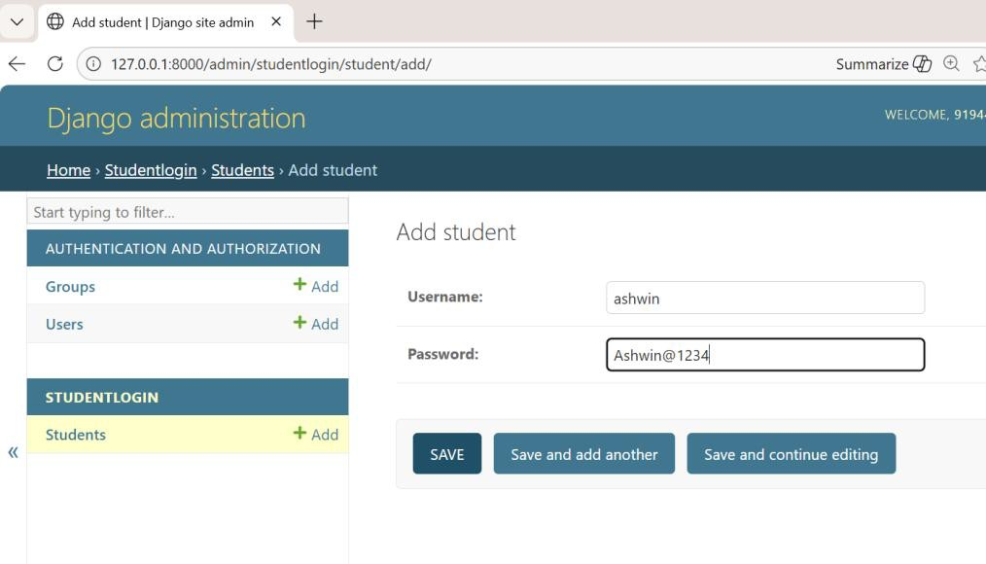
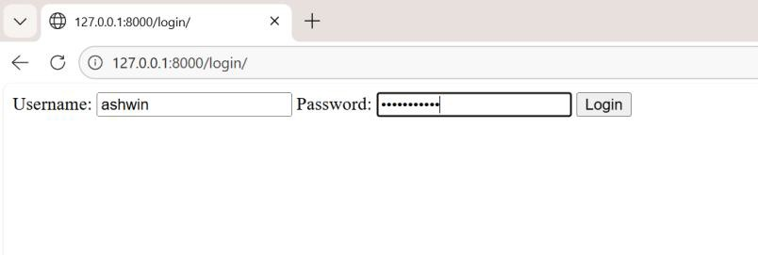
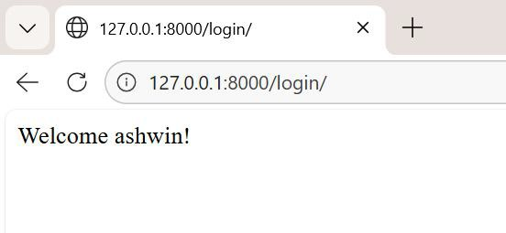

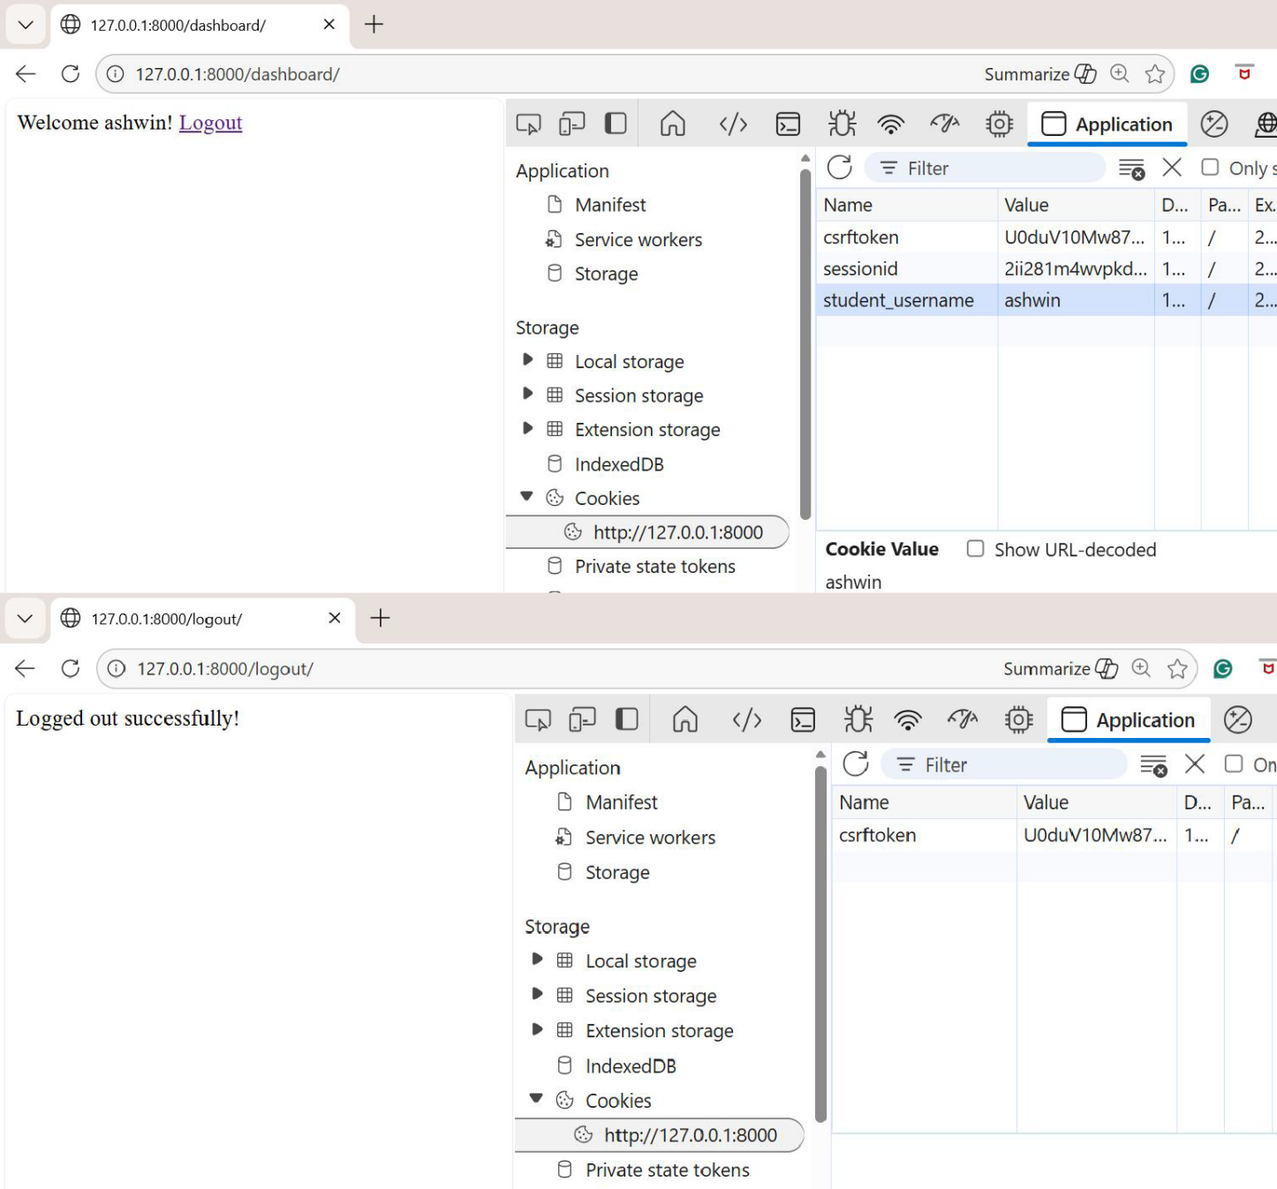

WEEK7: Create a Quiz Application using Django Framework along with SQLite3. Steps:
#Create an Environment python –m venv week7 cd week7/scripts/activate

# Install Django if not already pip install django

# Create a new Django project django-admin startproject quiz_app

cd quiz_app

# Create a quiz application inside the project python manage.py startapp quiz

quiz_app/ # Root project folder
│
├── manage.py # Django command-line utility
│
├── quiz_app/ # Project settings & configuration
│ ├── init .py
│ ├── settings.py # Global settings (DB, installed apps, etc.)

│ | ├── urls.py | # Root URL routing
│ | ├── asgi.py | # ASGI entry point

│ └── wsgi.py # WSGI entry point
│
├── quiz/ # Our quiz application
│ ├── init .py
│ ├── admin.py # Register models for Django admin
│ ├── apps.py # App configuration
│ ├── models.py # Database models (Question, Choice)
│ ├── views.py # Business logic (quiz & results)
│ ├── urls.py # App-specific URL routing
│ ├── tests.py # Unit tests
│ ├── migrations/ # Auto-generated DB migrations
│ │ └── init .py
│ └── templates/quiz/ # HTML templates
│ ├── quiz.html # Quiz page
│ └── result.html # Results page
│
├── db.sqlite3 # SQLite3 database file
└── static/ # (Optional) static files (CSS, JS, images)

Settings.py INSTALLED_APPS = [
'django.contrib.admin', 'django.contrib.auth', 'django.contrib.contenttypes', 'django.contrib.sessions', 'django.contrib.messages', 'django.contrib.staticfiles', 'quiz', # our app
]
DEBUG = True # Keep ON during development

ALLOWED_HOSTS = ['127.0.0.1', 'localhost'] TEMPLATES = [
{
'BACKEND': 'django.template.backends.django.DjangoTemplates', 'DIRS': [BASE_DIR / "templates"], # global templates folder 'APP_DIRS': True,
'OPTIONS': {
'context_processors': [ 'django.template.context_processors.debug', 'django.template.context_processors.request', 'django.contrib.auth.context_processors.auth', 'django.contrib.messages.context_processors.messages',
],
},
},
]

STATIC_URL = '/static/' STATICFILES_DIRS = [BASE_DIR / "static"]

LOGIN_REDIRECT_URL = '/' LOGOUT_REDIRECT_URL = '/'
LANGUAGE_CODE = 'en-in'
TIME_ZONE = 'Asia/Kolkata' USE_I18N = True
USE_TZ = True #security
CSRF_COOKIE_SECURE = True SESSION_COOKIE_SECURE = True SECURE_BROWSER_XSS_FILTER = True

#Models.py
from django.db import models

class Question(models.Model):
text = models.CharField(max_length=255)
def str (self): return self.text
class Choice(models.Model):

question = models.ForeignKey(Question, on_delete=models.CASCADE, related_name="choices")
text = models.CharField(max_length=255) is_correct = models.BooleanField(default=False)
def str (self): return self.text

Migrate database:
python manage.py makemigrations python manage.py migrate

#admin.py

from django.contrib import admin from .models import Question, Choice
admin.site.register(Question) admin.site.register(Choice)

#views.py
from django.shortcuts import render from .models import Question, Choice

def quiz_view(request):
questions = Question.objects.all()
return render(request, "quiz/quiz.html", {"questions": questions})
def result_view(request):
if request.method == "POST": score = 0
questions = Question.objects.all() for question in questions:
# Each question’s input name should be its ID in the template selected = request.POST.get(str(question.id))
if selected: try:
choice = Choice.objects.get(id=int(selected), question=question) if choice.is_correct:
score += 1
except Choice.DoesNotExist: pass

return render(request, "quiz/result.html", { "score": score,
"total": questions.count()
})
else:
# If someone visits result_view directly without POST return render(request, "quiz/result.html", {
"score": 0,
"total": 0
})

#quiz/urls.py(app level) from django.urls import path from . import views

urlpatterns = [
path('', views.quiz_view, name='quiz'), path('result/', views.result_view, name='result'),
]

#quiz_app/urls.py( Project level) from django.contrib import admin from django.urls import path, include
urlpatterns = [
path('admin/', admin.site.urls), path('', include('quiz.urls')),
]

Templates- quiz/templates/quiz/quiz.html
<form method="post" action="{% url 'result' %}">
{% csrf_token %}
{% for question in questions %}
<h3>{{ question.text }}</h3>
{% for choice in question.choices.all %}
<input type="radio" name="{{ question.id }}" value="{{ choice.id }}">
{{ choice.text }}<br>
{% endfor %}
{% endfor %}
<button type="submit">Submit</button>
</form>

Results.html
<h2>Your Score: {{ score }} / {{ total }}</h2>

<a href="{% url 'quiz' %}">Try Again</a>

Run Project:
python manage.py runserver

OUTPUT:
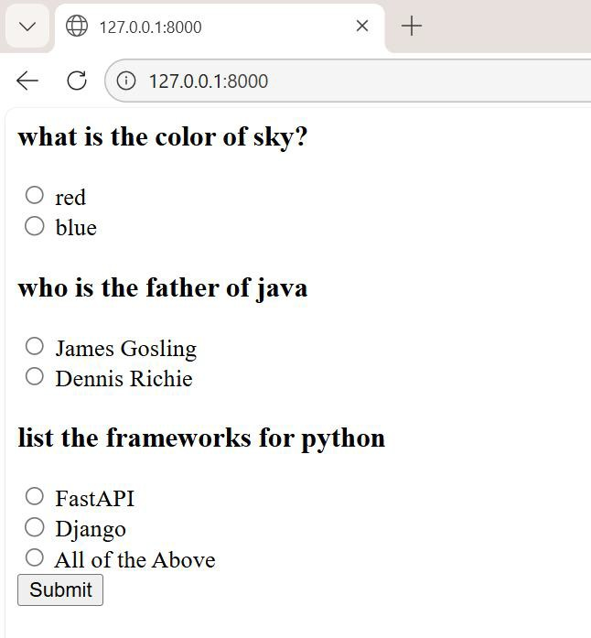

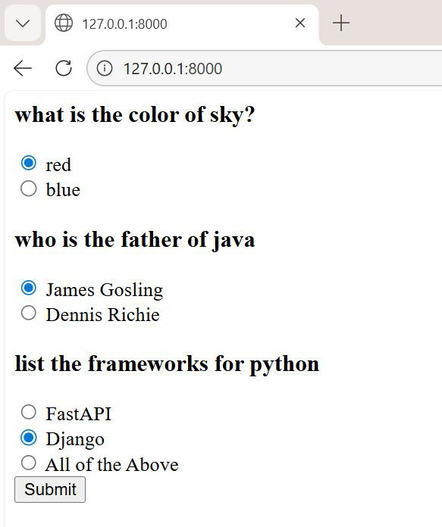

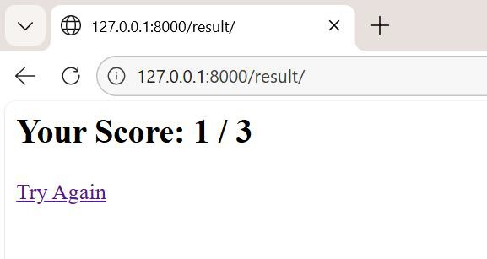

WEEK8: Create a Django application using generic views and forms

Generic views are part of Django’s class-based views (CBVs) system. They abstract common patterns like listing objects, showing details, creating, updating, and deleting records.
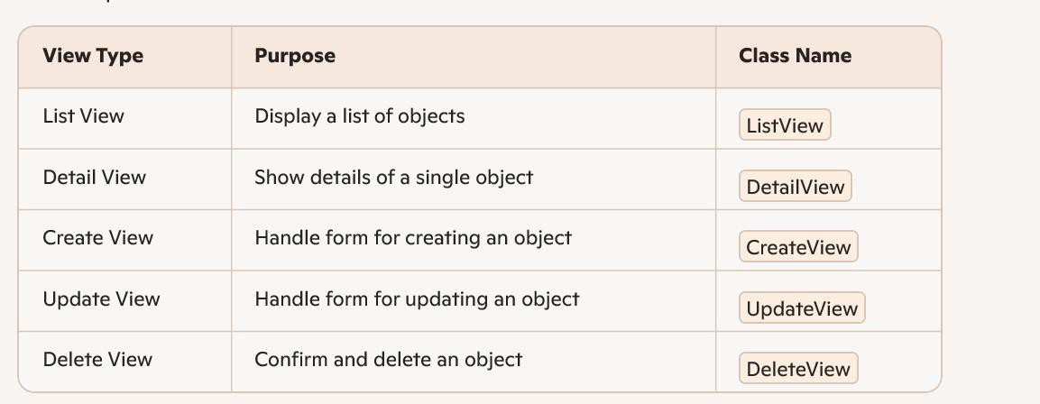

Generic forms refer to Django’s built-in form classes that simplify form creation and handling.
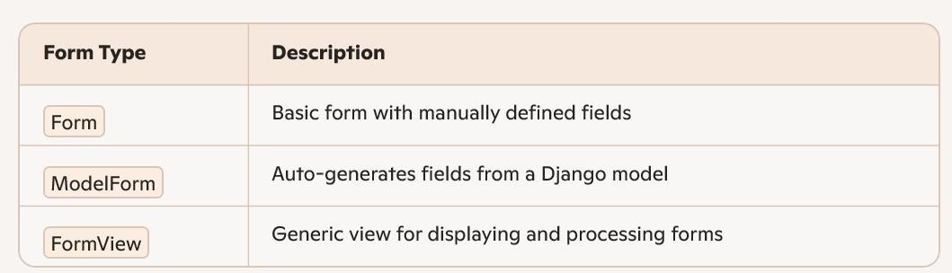

PROGRAM:

Step1: create a project and app
#Create an Environment python –m venv week8 cd week8/scripts/activate

django-admin startproject library cd library
python manage.py startapp bookmanager

Add 'bookmanager' to INSTALLED_APPS in library/settings.py.

Step2: Models (bookmanager/models.py)
from django.db import models class Book(models.Model):
title = models.CharField(max_length=200) author = models.CharField(max_length=100) published_date = models.DateField()
genre = models.CharField(max_length=50) def str (self):
return self.title
step3: Run These following commands python manage.py makemigrations python manage.py migrate

step4: Forms (bookmanager/forms.py)
from django import forms from .models import Book
class BookForm(forms.ModelForm): class Meta:
model = Book

fields = ['title', 'author', 'published_date', 'genre']

Step5: Views (bookmanager/Views.py)
from django.views.generic import ListView, DetailView, CreateView, UpdateView,
DeleteView

from django.urls import reverse_lazy from .models import Book
from .forms import BookForm class BookListView(ListView):
model = Book
template_name = 'book_list.html' class BookDetailView(DetailView):
model = Book
template_name = 'book_detail.html' class BookCreateView(CreateView):
model = Book form_class = BookForm
template_name = 'book_form.html' success_url = reverse_lazy('book_list')
class BookUpdateView(UpdateView): model = Book
form_class = BookForm template_name = 'book_form.html' success_url = reverse_lazy('book_list')
class BookDeleteView(DeleteView):

model = Book
template_name = 'book_confirm_delete.html' success_url = reverse_lazy('book_list')

Step6: URLs (bookmanager/urls.py)
from django.urls import path
from .views import BookListView, BookDetailView, BookCreateView,
BookUpdateView, BookDeleteView urlpatterns = [
path('', BookListView.as_view(), name='book_list'), path('book/<int:pk>/', BookDetailView.as_view(), name='book_detail'), path('book/add/', BookCreateView.as_view(), name='book_add'),
path('book/<int:pk>/edit/', BookUpdateView.as_view(), name='book_edit'), path('book/<int:pk>/delete/', BookDeleteView.as_view(), name='book_delete'),
]

Step7: Include this in the main library/urls.py:
from django.contrib import admin from django.urls import path, include urlpatterns = [
path('admin/', admin.site.urls), path('', include('bookmanager.urls')),
]

Step8: in bookmanager/templates folder
- 1.Base.html

<!DOCTYPE html>
<html>
<head>
<title>Book Manager</title>
</head>
<body>
<h1>Book Manager</h1>
<nav>
<a href="{% url 'book_list' %}">Home</a> |
<a href="{% url 'book_add' %}">Add Book</a>
</nav>
<hr>
{% block content %}{% endblock %}
</body>
</html>
  - Book_list.html
{% extends 'base.html' %}
{% block content %}
<h2>Book List</h2>
<ul>
{% for book in object_list %}
<li>
<a href="{% url 'book_detail' book.pk %}">{{ book.title }}</a> by
{{ book.author }}

</li>
{% empty %}
<li>No books available.</li>
{% endfor %}
</ul>
{% endblock %}
  - :book_detail.html
{% extends 'base.html' %}
{% block content %}
<h2>{{ object.title }}</h2>
<p><strong>Author:</strong> {{ object.author }}</p>
<p><strong>Published:</strong> {{ object.published_date }}</p>
<p><strong>Genre:</strong> {{ object.genre }}</p>
<a href="{% url 'book_edit' object.pk %}">Edit</a> |
<a href="{% url 'book_delete' object.pk %}">Delete</a>
{% endblock %}
  - book_form.html
{% extends 'base.html' %}
{% block content %}
<h2>{% if object %}Edit{% else %}Add{% endif %} Book</h2>
<form method="post">
{% csrf_token %}
{{ form.as_p }}
<button type="submit">Save</button>

</form>
{% endblock %}
  - book_confirm-delete.html
{% extends 'base.html' %}
{% block content %}
<h2>Confirm Delete</h2>
<p>Are you sure you want to delete "{{ object.title }}"?</p>
<form method="post">
{% csrf_token %}
<button type="submit">Yes, delete</button>
<a href="{% url 'book_list' %}">Cancel</a>
</form>
{% endblock %}

Run application: python manage.py runserver

OUTPUT:
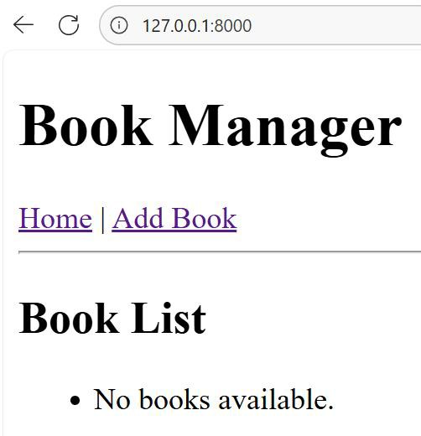

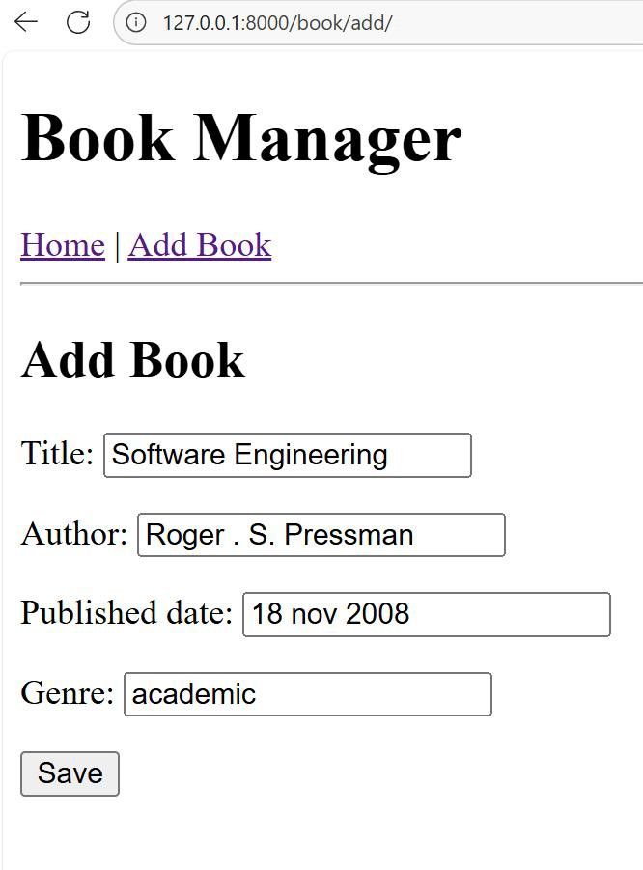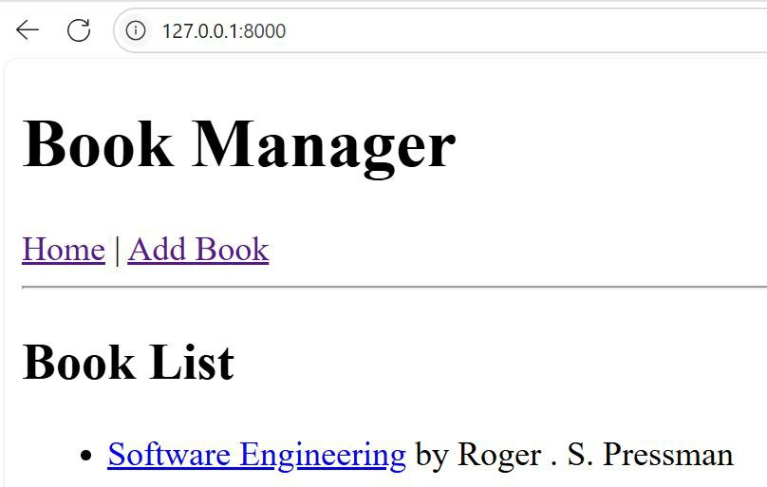

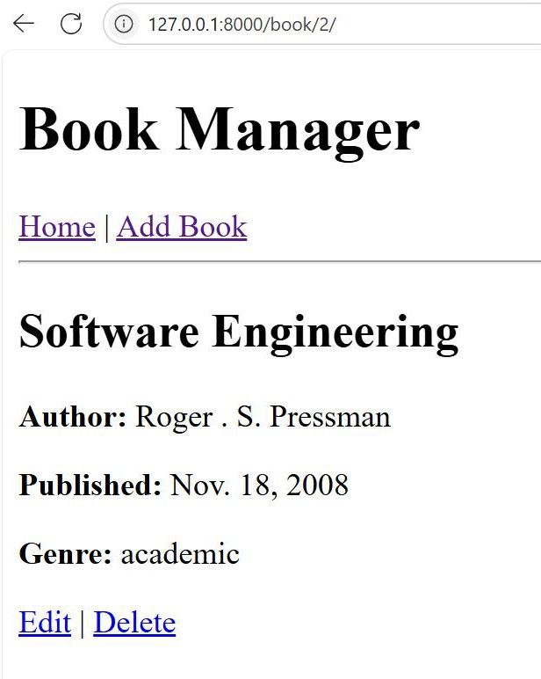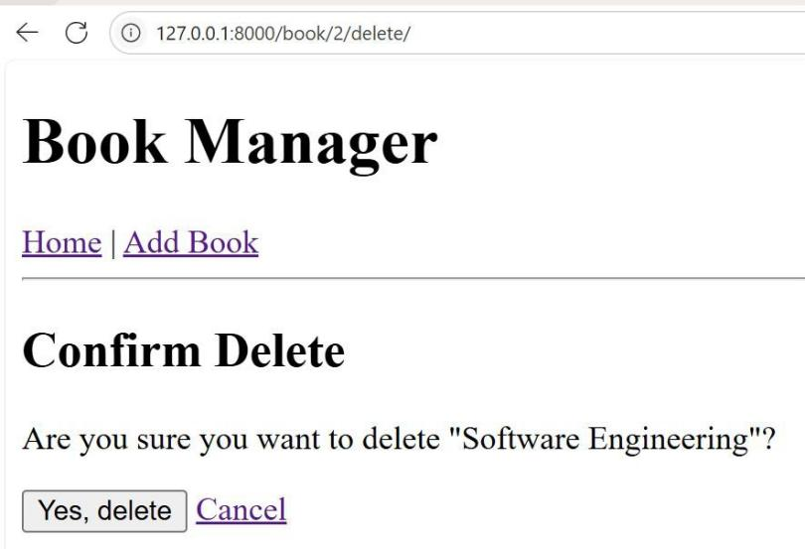

WEEK9: Create an Application for Working with Mails using Django Framework Steps:
#Create an Environment python –m venv week9 cd week9/scripts/activate # Install Django
pip install django # Create project
django-admin startproject mail_app cd mail_app
# Create mail application python manage.py startapp mail
mail_app/ # Root project folder
│
├── manage.py # Django command-line utility
│
├── mail_app/ # Project settings & configuration
│ ├── init .py
│ ├── settings.py # Global settings (DB, email backend, auth)
│ ├── urls.py # Root URL routing
│ ├── asgi.py # ASGI entry point
│ └── wsgi.py # WSGI entry point
│
├── mail/ # Our mail application
│ ├── init .py
│ ├── admin.py # Register models for Django admin

│ | ├── apps.py | # App configuration
│ | ├── models.py | # Mail model (sender, recipient, subject, body)
│ | ├── forms.py | # Forms (MailForm, RegisterForm)
│ | ├── views.py | # Business logic (inbox, compose, login, register)
│ | ├── urls.py | # App-specific URL routing
│ | ├── tests.py | # Unit tests
│ ├── migrations/ # Auto-generated DB migrations
│ │ └── init .py
│ └── templates/mail/ # HTML templates

│ | ├── inbox.html | # Inbox page
│ | ├── compose.html | # Compose mail page
│ | ├── login.html | # Login page
│ | └── register.html | # Register page
│
├── db.sqlite3 # SQLite3 database file
└── static/ # (Optional) static files (CSS, JS, images)
└── mail/ # App-specific static files
├── style.css # Styling for pages
└── scripts.js # Optional JS

INSTALLED_APPS = [
'django.contrib.admin', 'django.contrib.auth', 'django.contrib.contenttypes', 'django.contrib.sessions', 'django.contrib.messages',

'django.contrib.staticfiles', 'mail', # our app
]

# Email backend (SMTP example: Gmail)
EMAIL_BACKEND = 'django.core.mail.backends.smtp.EmailBackend' EMAIL_HOST = 'smtp.gmail.com'
EMAIL_PORT = 587 EMAIL_USE_TLS = True
EMAIL_HOST_USER = 'your_email@gmail.com' EMAIL_HOST_PASSWORD = 'your_password_or_app_password'

LOGIN_REDIRECT_URL = '/inbox/' # after login, go to inbox LOGOUT_REDIRECT_URL = '/login/' # after logout, go to login page

#models.py
from django.db import models
from django.contrib.auth.models import User class Mail(models.Model):
sender = models.EmailField() recipient = models.EmailField()
subject = models.CharField(max_length=255) body = models.TextField()
timestamp = models.DateTimeField(auto_now_add=True) owner = models.ForeignKey(User, on_delete=models.CASCADE) def str (self):

return f"{self.subject} ({self.sender} → {self.recipient})" #forms.py
from django import forms
from django.contrib.auth.models import User
from django.contrib.auth.forms import UserCreationForm

class RegisterForm(UserCreationForm): email = forms.EmailField(required=True)

class Meta: model = User
fields = ["username", "email", "password1", "password2"]

#views.py
from django.shortcuts import render, redirect
from django.contrib.auth.decorators import login_required from django.contrib.auth import login, logout
from django.contrib.auth.forms import AuthenticationForm from django.core.mail import send_mail
from django.conf import settings

from .forms import MailForm, RegisterForm from .models import Mail

# Inbox View @login_required
def inbox_view(request):
mails = Mail.objects.filter(owner=request.user).order_by('-timestamp') return render(request, "mail/inbox.html", {"mails": mails})

# ✉ Compose Mail View @login_required
def compose_view(request):
if request.method == "POST": form = MailForm(request.POST) if form.is_valid():
recipient = form.cleaned_data['recipient'] subject = form.cleaned_data['subject'] body = form.cleaned_data['body']

# Send email via SMTP
send_mail(subject, body, settings.EMAIL_HOST_USER, [recipient])

# Save to DB Mail.objects.create(
sender=settings.EMAIL_HOST_USER, recipient=recipient,
subject=subject,

body=body, owner=request.user
)
return redirect("inbox")
else:
form = MailForm()
return render(request, "mail/compose.html", {"form": form})

# Login View
def login_view(request):
if request.method == "POST":
form = AuthenticationForm(request, data=request.POST) if form.is_valid():
user = form.get_user() login(request, user) return redirect("inbox")
else:
form = AuthenticationForm()
return render(request, "mail/login.html", {"form": form})

# Logout View @login_required
def logout_view(request): logout(request)

return redirect("login")

# Register View
def register_view(request):
if request.method == "POST":
form = RegisterForm(request.POST) if form.is_valid():
user = form.save()
login(request, user) # auto-login after registration return redirect("inbox")
else:
form = RegisterForm()
return render(request, "mail/register.html", {"form": form})

urls.py (applevel)
from django.urls import path from . import views

urlpatterns = [
path('inbox/', views.inbox_view, name='inbox'), path('compose/', views.compose_view, name='compose'),
path('login/', views.login_view, name='login'), # already added earlier path('logout/', views.logout_view, name='logout'),
path('register/', views.register_view, name='register'), # new
]

Urls.py(project level)
from django.contrib import admin from django.urls import path, include

urlpatterns = [
path('admin/', admin.site.urls), path('', include('mail.urls')),
]

Templates Register.html
{% load static %}
<!DOCTYPE html>
<html lang="en">
<head>
<meta charset="UTF-8">
<title>Register</title>
<link rel="stylesheet" href="{% static 'mail/style.css' %}">
<script src="{% static 'mail/script.js' %}"></script>
</head>
<body>
<h2>Create an Account</h2>

<!-- Registration Form -->
<form method="post">

{% csrf_token %}
{{ form.as_p }}
<button type="submit">Register</button>
</form>

<!-- Navigation -->
<p>Already have an account? <a href="{% url 'login' %}">Login here</a></p>
</body>
</html> Login.html
<p>Don't have an account? <a href="{% url 'register' %}">Register here</a></p>

Inbox.html
{% load static %}
<!DOCTYPE html>
<html lang="en">
<head>
<meta charset="UTF-8">
<title>Inbox</title>
<link rel="stylesheet" href="{% static 'mail/style.css' %}">
<script src="{% static 'mail/script.js' %}"></script>
</head>
<body>
<h2>Your Inbox</h2>

<!-- Navigation -->

<p>
<a href="{% url 'compose' %}">Compose Mail</a> |
<a href="{% url 'logout' %}">Logout</a>
</p>

<!-- Inbox List -->
<ul>
{% for mail in mails %}
<li>
<b>{{ mail.subject }}</b><br>
From: {{ mail.sender }} → To: {{ mail.recipient }}<br>
<small>{{ mail.timestamp }}</small><br>
<p>{{ mail.body|truncatewords:20 }}</p>
</li>
{% empty %}
<li>No mails yet.</li>
{% endfor %}
</ul>
</body>
</html>

Compose .html
{% load static %}
<!DOCTYPE html>
<html lang="en">
<head>

<meta charset="UTF-8">
<title>Compose Mail</title>
<link rel="stylesheet" href="{% static 'mail/style.css' %}">
<script src="{% static 'mail/script.js' %}"></script>
</head>
<body>
<h2>Compose Mail</h2>

<!-- Navigation -->
<p>
<a href="{% url 'inbox' %}">Inbox</a> |
<a href="{% url 'logout' %}">Logout</a>
</p>

<!-- Compose Form -->
<form method="post">
{% csrf_token %}
{{ form.as_p }}
<button type="submit">Send Mail</button>
</form>
</body>
</html> Login.html
{% load static %}
<!DOCTYPE html>
<html lang="en">

<head>
<meta charset="UTF-8">
<title>Login</title>
<link rel="stylesheet" href="{% static 'mail/style.css' %}">
<script src="{% static 'mail/script.js' %}"></script>
</head>
<body>
<h2>Login</h2>

<!-- Login Form -->
<form method="post">
{% csrf_token %}
{{ form.as_p }}
<button type="submit">Login</button>
</form>

<!-- Navigation -->
<p>Don't have an account? <a href="{% url 'register' %}">Register here</a></p>
</body>
</html> Logout.html
{% load static %}
<!DOCTYPE html>
<html lang="en">
<head>

<meta charset="UTF-8">
<title>Logout</title>
<link rel="stylesheet" href="{% static 'mail/style.css' %}">
</head>
<body>
<h2>You have been logged out</h2>
<p><a href="{% url 'login' %}">Login again</a></p>
</body>
</html>

Styles.css
/* General page styling */ body {
font-family: Arial, sans-serif; background-color: #f4f6f9; margin: 0;
padding: 0;
}

/* Header */ h2 {
color: #333;
text-align: center; margin-top: 20px;
}

/* Form styling */ form {
max-width: 400px; margin: 20px auto; padding: 20px; background: #fff; border-radius: 8px;
box-shadow: 0px 2px 6px rgba(0,0,0,0.1);
}

form input, form textarea, form button { width: 100%;
padding: 10px; margin: 8px 0; border-radius: 5px; border: 1px solid #ccc;
}

/* Buttons */ button {
background-color: #007bff; color: white;
border: none; cursor: pointer; font-weight: bold;
}

button:hover {
background-color: #0056b3;
}

/* Inbox list */ ul {
list-style-type: none; padding: 0;
}

ul li {
background: #fff; margin: 10px auto; padding: 15px; border-radius: 6px; max-width: 600px;
box-shadow: 0px 2px 4px rgba(0,0,0,0.1);
}

ul li b {
color: #007bff;
}

/* Navigation links */ a {

color: #007bff;
text-decoration: none;
}

a:hover {
text-decoration: underline;
}
Script.js
// Wait until the DOM is fully loaded document.addEventListener("DOMContentLoaded", function() {

// Confirmation before sending mail
const composeForm = document.querySelector("form");
if (composeForm && window.location.pathname.includes("compose")) { composeForm.addEventListener("submit", function(event) {
const confirmSend = confirm("Are you sure you want to send this mail?"); if (!confirmSend) {
event.preventDefault(); // cancel submission
} else {
// Show toast notification after sending showToast("✅ Mail sent successfully!");
}
});
}

// Highlight inbox items on hover

const inboxItems = document.querySelectorAll("ul li"); inboxItems.forEach(item => {
item.addEventListener("mouseover", () => { item.style.backgroundColor = "#e9f5ff"; // light blue highlight
});
item.addEventListener("mouseout", () => { item.style.backgroundColor = "#fff"; // reset
});
});

// Auto-focus first input field (login/register/compose) const firstInput = document.querySelector("form input"); if (firstInput) {
firstInput.focus();
}

// Password visibility toggle (login/register forms)
const passwordFields = document.querySelectorAll("input[type='password']"); passwordFields.forEach(field => {
const toggle = document.createElement("span"); toggle.textContent = " ";
toggle.style.cursor = "pointer"; toggle.style.marginLeft = "10px"; field.parentNode.appendChild(toggle);

toggle.addEventListener("click", () => {

field.type = field.type === "password" ? "text" : "password";
});
});

// Toast notification function function showToast(message) {
const toast = document.createElement("div"); toast.textContent = message; toast.style.position = "fixed"; toast.style.bottom = "20px";
toast.style.right = "20px"; toast.style.background = "#28a745"; toast.style.color = "#fff"; toast.style.padding = "10px 20px"; toast.style.borderRadius = "5px";
toast.style.boxShadow = "0px 2px 6px rgba(0,0,0,0.2)"; document.body.appendChild(toast);

setTimeout(() => toast.remove(), 3000); // disappear after 3s
}
});

Run application
python manage.py createsuperuser python manage.py collectstatic python manage.py runserver

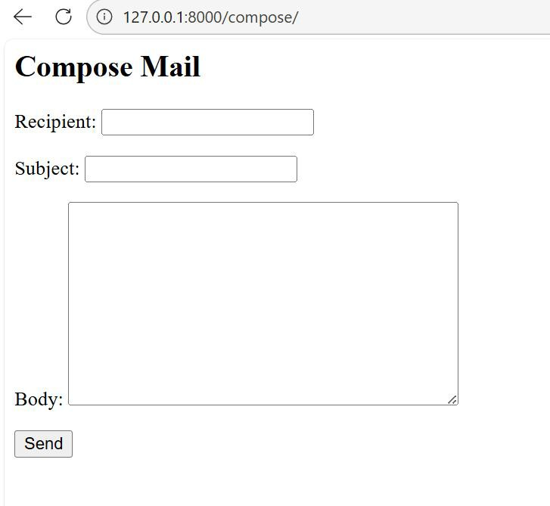

WEEK10:Create an application that fetches the weather information from openweathermap.org and the display the current and historical weather information using graphical representation using chart.js implement using Django

Project Strucuture:

weather_project/

├─ manage.py

├─ .env

├─ requirements.txt

├─ weather_project/

│ ├─ init .py

│ ├─ settings.py

│ ├─ urls.py

│ ├─ asgi.py

│ └─ wsgi.py

└─ weather/

├─ init .py

├─ apps.py

├─ urls.py

├─ views.py

├─ services.py

├─ models.py

├─ forms.py

├─ templates/

│ └─ weather/

│ └─ dashboard.html

└─ static/

└─ weather/

├─ styles.css

└─ charts.js

Step1:

Create environment pip install django
pip install django requests

then create django project with weather_Project Create weather app
django-admin startproject weather_project cd weather_project
python manage.py startapp weather_app

Step2: create a text file Requirements.txt Django>=4.2[new version] requests>=2.31
python-dotenv>=1.0 in .env file
DJANGO_SECRET_KEY=your-dev-secret OPENWEATHER_API_KEY=your_openweather_api_key DEBUG=True ALLOWED_HOSTS=localhost,127.0.0.1

Settings.py

INSTALLED_APPS = [

"django.contrib.admin", "django.contrib.auth", "django.contrib.contenttypes", "django.contrib.sessions", "django.contrib.messages", "django.contrib.staticfiles", "weather",
]

Project url-weather_project/urls.py from django.contrib import admin from django.urls import path, include

urlpatterns = [

path("admin/", admin.site.urls), path("", include("weather.urls")),
]

Applevel- weather/urls.py from django.urls import path from .views import dashboard urlpatterns = [
path("", dashboard, name="dashboard"),

]

Step3:

Utils.py

# utils.py import requests
from django.conf import settings

def fetch_weather(city, country_code="IN"): api_key = settings.OPENWEATHER_API_KEY
url =
f"http://api.openweathermap.org/data/2.5/weather?q={city},{country_code}&ap pid={api_key}&units=metric"
response = requests.get(url) data = response.json() return {
"city": city,

"country_code": country_code, "temp_c": data["main"]["temp"],
"humidity": data["main"]["humidity"],

"wind_speed": data["wind"]["speed"],

}

Forms.py

from django import forms

from .models import WeatherSnapshot

class CityForm(forms.Form):

city = forms.ChoiceField(label="Choose City")

def init (self, *args, **kwargs): super(). init (*args, **kwargs)
# Populate dropdown with distinct cities from WeatherSnapshot cities = WeatherSnapshot.objects.values_list("city", flat=True).distinct() self.fields["city"].choices = [(c, c) for c in cities]

Models.py

from django.db import models

from django.core.validators import MinValueValidator, MaxValueValidator

class WeatherSnapshot(models.Model): city = models.CharField(max_length=100)
country_code = models.CharField(max_length=2, blank=True) # e.g., "IN" timestamp = models.DateTimeField(auto_now_add=True)

temp_c = models.FloatField(

validators=[MinValueValidator(-100), MaxValueValidator(60)]

)

humidity = models.IntegerField( validators=[MinValueValidator(0), MaxValueValidator(100)]

)

wind_speed = models.FloatField( validators=[MinValueValidator(0)]
)

class Meta:

ordering = ["-timestamp"] indexes = [
models.Index(fields=["city"]), models.Index(fields=["timestamp"]),
]

def str (self):

return f"{self.city} ({self.country_code}) - {self.temp_c}°C at
{self.timestamp:%Y-%m-%d %H:%M}"

services.py import requests
from django.conf import settings

BASE_URL = "https://api.openweathermap.org/data/2.5"

API_KEY = settings.OPENWEATHER_API_KEY

def get_current_weather(city: str, country_code: str = ""): if not API_KEY:
raise RuntimeError("Missing OPENWEATHER_API_KEY") q = f"{city},{country_code}" if country_code else city
url = f"{BASE_URL}/weather"

params = {"q": q, "appid": API_KEY, "units": "metric"} r = requests.get(url, params=params, timeout=10) r.raise_for_status()
data = r.json() return {
"city": data["name"], "lat": data["coord"]["lat"],
"lon": data["coord"]["lon"],

"temp_c": data["main"]["temp"],

"humidity": data["main"]["humidity"],

"wind_speed": data["wind"]["speed"],

"description": data["weather"][0]["description"].title(),

"icon": data["weather"][0]["icon"],

}

def get_forecast_5day(city: str, country_code: str = ""): if not API_KEY:
raise RuntimeError("Missing OPENWEATHER_API_KEY") q = f"{city},{country_code}" if country_code else city
url = f"{BASE_URL}/forecast"

params = {"q": q, "appid": API_KEY, "units": "metric"} r = requests.get(url, params=params, timeout=10) r.raise_for_status()
data = r.json() points = []
for item in data.get("list", []): points.append({
"dt_txt": item["dt_txt"], "temp_c": item["main"]["temp"],
"humidity": item["main"]["humidity"],

"wind_speed": item["wind"]["speed"],

})

return points

views.py # views.py
from django.shortcuts import render

from django.utils.timezone import localtime from .models import WeatherSnapshot from .forms import CityForm

def weather_chart_view(request): city = None
labels, temp_data, humidity_data, wind_data = [], [], [], []

if request.method == "POST": form = CityForm(request.POST) if form.is_valid():
city = form.cleaned_data["city"]

qs = WeatherSnapshot.objects.filter(city=city).order_by("-timestamp")[:10] qs = list(reversed(qs))

labels = [localtime(s.timestamp).strftime("%Y-%m-%d %H:%M") for s in
qs]

temp_data = [s.temp_c for s in qs] humidity_data = [s.humidity for s in qs] wind_data = [s.wind_speed for s in qs]
else:

form = CityForm()

return render(request, "weather/chart.html", { "form": form,
"city": city, "labels": labels,
"temp_data": temp_data, "humidity_data": humidity_data, "wind_data": wind_data,
})

step4:

templates folder -dashboard.html

{% load static %}

<!DOCTYPE html>

<html lang="en">

<head>

<meta charset="utf-8" />

<title>Weather dashboard</title>

<link rel="stylesheet" href="{% static 'weather/styles.css' %}">

<script src="https://cdn.jsdelivr.net/npm/chart.js"></script>

</head>

<body>

<main class="container">

<h1>Weather dashboard</h1>

<form method="post" class="city-form">

{% csrf_token %}

{{ form.as_p }}

<button type="submit">Update</button>

</form>

{% if messages %}

<ul class="messages">

{% for m in messages %}

<li class="{{ m.tags }}">{{ m }}</li>

{% endfor %}

</ul>

{% endif %}

{% if current %}

<section class="current">

<h2>Current weather — {{ current.city }}</h2>

<div class="current-grid">

<div>

<p><strong>Temperature:</strong> {{ current.temp_c }} °C</p>

<p><strong>Humidity:</strong> {{ current.humidity }} %</p>

<p><strong>Wind:</strong> {{ current.wind_speed }} m/s</p>

<p><strong>Conditions:</strong> {{ current.description }}</p>

</div>

<div>

<img alt="icon"
src="https://openweathermap.org/img/wn/{{ current.icon }}@2x.png">

</div>

</div>

</section>

{% endif %}

<section class="charts">

<h2>5-day forecast (3-hour intervals)</h2>

<canvas id="forecastTempChart"></canvas>

<canvas id="forecastHumidityChart"></canvas>

<h2>Local historical snapshots (last 30)</h2>

<canvas id="historicalTempChart"></canvas>

<canvas id="historicalWindChart"></canvas>

</section>

</main>

{{ forecast_points|json_script:"forecast-data" }}

{{ historical_points|json_script:"historical-data" }}

<script src="{% static 'weather/charts.js' %}"></script>

</body>

</html>

Step5: Static/charts.js

<h2>Weather Trends</h2>

<canvas id="weatherChart"></canvas>

<script src="https://cdn.jsdelivr.net/npm/chart.js"></script>

<script>

// These arrays come from your Django context

const labels = ["2026-01-20 18:00", "2026-01-20 19:00", "2026-01-20 20:00"];

const tempData = [24.5, 23.8, 22.9];

const humidityData = [60, 65, 70];

const windData = [3.2, 2.8, 2.5];

new Chart(document.getElementById('weatherChart'), { type: 'line',
data: {

labels: labels, datasets: [
{

label: 'Temperature (°C)', data: tempData, borderColor: 'red',
backgroundColor: 'rgba(255,0,0,0.2)', fill: false,
tension: 0.3

},

{

label: 'Humidity (%)', data: humidityData, borderColor: 'blue',
backgroundColor: 'rgba(0,0,255,0.2)', fill: false,
tension: 0.3

},

{

label: 'Wind Speed (m/s)', data: windData, borderColor: 'green',
backgroundColor: 'rgba(0,255,0,0.2)', fill: false,
tension: 0.3

}

]

},

options: { responsive: true,

plugins: {

legend: { position: 'top' }, tooltip: { enabled: true }
},

scales: { x: {
title: { display: true, text: 'Timestamp' }

},

y: {

title: { display: true, text: 'Values' }

}

}

}

});

</script>

Styles.css body {
font-family: system-ui, sans-serif; margin: 0; background: #f7f9fb; color: #2c3e50;
}

.container { max-width: 1000px; margin: 2rem auto; padding: 0 1rem; }

.city-form { display: flex; gap: 1rem; align-items: flex-end; }

.city-form p { margin: 0; }

.current-grid { display: grid; grid-template-columns: 1fr 120px; gap: 1rem; align-items: center; }
.messages { list-style: none; padding: 0; }

.messages li { margin: .5rem 0; padding: .5rem .75rem; border-radius: 6px; }

.messages li.error { background: #fdecea; color: #c0392b; }

canvas { margin: 1rem 0; background: #fff; border: 1px solid #eaecef; border-radius: 8px; padding: .5rem; }
Run the application Install the dependencies
pip install -r requirements.txt

- Add your OpenWeatherMap API key to .env.
- Make migrations and migrate python manage.py runserver

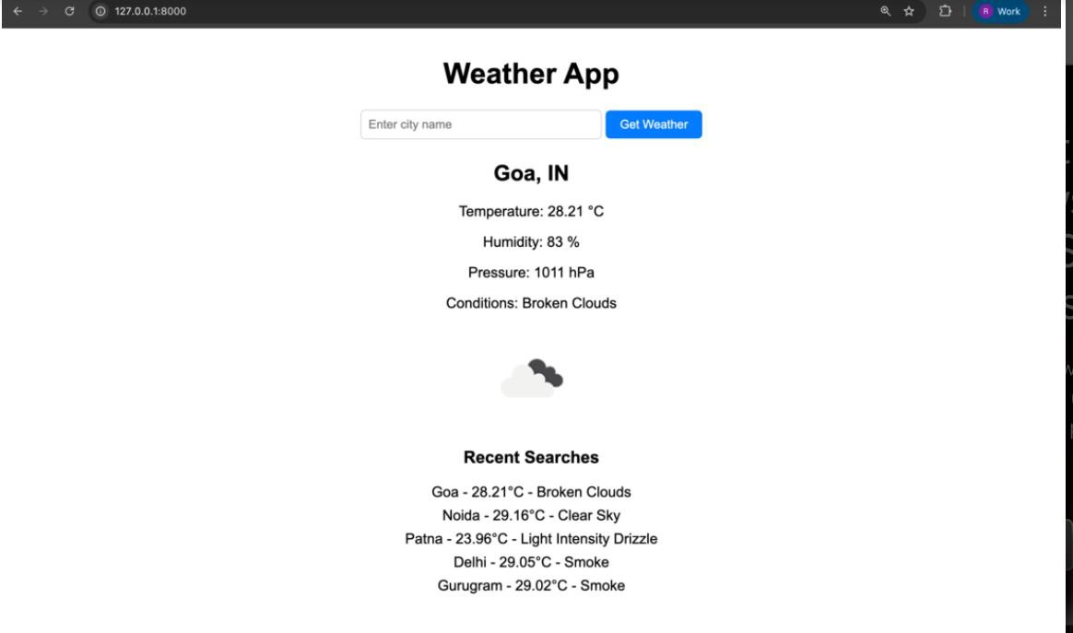

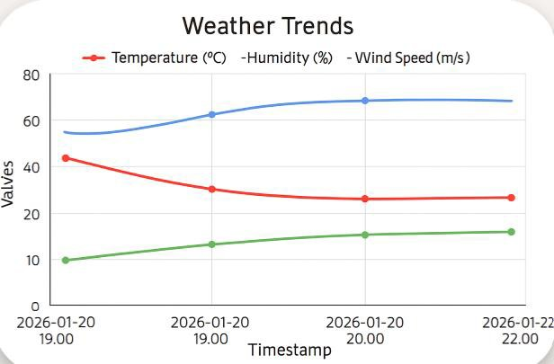

WEEK11: Case Study: Django Application for VJIT Student Portal and deploy it into GitHub.

Case study : VJIT STUDENT PORTAL
django-admin startproject vjit_site cd vjit_site
python manage.py startapp main

Apps to create
main → Homepage, About, Contact academics → Departments, Courses admissions → Admission info, forms events → News, Events, Announcements students → Student portal, results, notices

Models.py
# academics/models.py
from django.db import models

class Department(models.Model):
name = models.CharField(max_length=100) hod = models.CharField(max_length=100) description = models.TextField() contact_email = models.EmailField()

def str (self): return self.name

views.py
# main/views.py
from django.shortcuts import render

def home(request):
return render(request, 'main/home.html')
Project Level url mapping # vjit_site/urls.py
from django.contrib import admin from django.urls import path, include from main import views as main_views urlpatterns = [
path('admin/', admin.site.urls),
path('', main_views.home, name='home'), path('academics/', include('academics.urls')),
]
<!DOCTYPE html>
<html>
<head>
<title>VJIT - Home</title>
</head>
<body>
<h1>Welcome to Vidya Jyothi Institute of Technology</h1>

<nav>
<a href="/academics/">Academics</a> |
<a href="/admissions/">Admissions</a> |
<a href="/events/">Events</a>
</nav>
</body>
</html>
Admin.py
# academics/admin.py
from django.contrib import admin from .models import Department admin.site.register(Department)

Run application
Python manage.py runserver
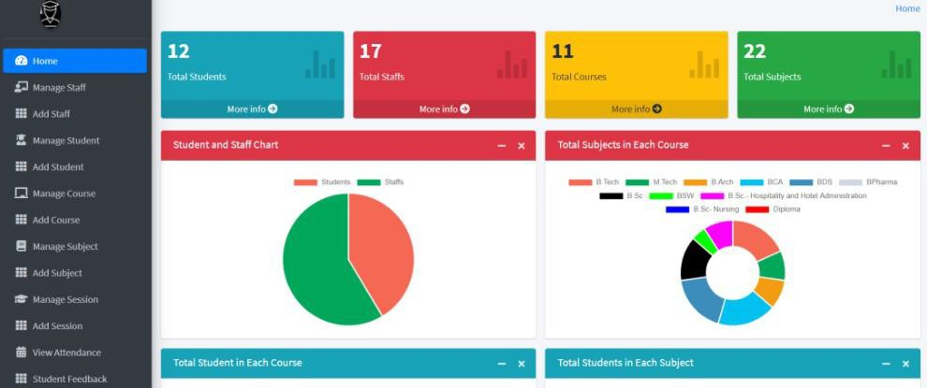

Step2: Deploying a Project to GitHub
- Create a GitHub account
Install Git on your computer (git --version to check). git init
git add .
git commit -m "Initial commit"
- Create a repository on GitHub
Go to GitHub → click New Repository
Give it a name (e.g., VJIT-app).
Choose Public (so others can see it) or Private.

Link your local project to GitHub
git remote add origin https://github.com/your-username/vjit-app.git git branch -M main
git push -u origin main
Hosting a Website with GitHub Pages

If your project is a static site (HTML, CSS, JS):
- Push your code to GitHub as above.
- Go to your repo → Settings → Pages.
- Under “Source,” select branch main and folder /root (or /docs).
- Save → GitHub will give you a live URL like: https://your-username.github.io/vjit-app/
GitHub itself cannot run Django apps (because Django needs Python + a server). GitHub Pages only hosts static HTML/CSS/JS.
  - PythonAnywhere → Free tier, good for small Django apps OR
  - Heroku: Free tier for Django apps, integrates with GitHub OR
  - Vercel/Render: Modern hosting, supports Django with some setup

Deploy with Render
- Push your Django project to GitHub (step 1 above).
- Go to Render.
- Create a new Web Service → connect your GitHub repo.
- Set Build Command:
pip install -r requirements.txt python manage.py migrate

gunicorn vjit_project.wsgi:application

Add environment variables
Deploy → Render gives you a live URL (e.g., https://vjit-django.onrender.com).

